LTU Nationwide GNSS Tolling System
ICD
LTU Fuel Card Interface
Doc No. 20009
Version 2.0

Author | Juan Pablo Gottret
Reviewed: | Roman Trinko
Approved by: | Hans Gidoff

Overview of changes.
No. | Version | Status | Date | Contributor | Type of the change
1 | 0.1 | DRAFT | 18.03.2026 | Juan Pablo Gottret | First Version
2 | 1.0 | Released | 25.03.2026 | Roman Trinko | Minor change
3 | 2.0 | Released | 03.06.2026 | Franco Di Stefano | Completely reworked based meetings with FCP and received documentation
Table 1 Overview of changes

Reference to the status, versions and data classification.
Status:
Draft | the document is being processed
Released | the document has been checked and released, it can only be modified if the version number is updated.
Obsolete | the document is not valid anymore
Versions:
0.1, 0.2 | draft versions
1.0 | first released version with the status “Released“
1.1, 1.2, etc. | draft versions, that supplement version 1.0
2.0 | second released version with the status “Released”
Data classification
Public |  | No restriction
Internal |  | Restricted to internal and external Kapsch employees
Confidential |  | Restricted to selected active directory and/or sharepoint groups (default)
Secret |  | Restricted to selected employees, server encryption needed

Page
Table of Contents
1 General 8
1.1 Purpose of the document 8
2 Requirements for Fuel Card Providers 8
2.1 Integration Method 8
2.2 IFrame to enter Fuel Card details 8
2.3 Required API Methods 9
2.3.1 Tokenize 9
2.3.1.1 Purpose 9
2.3.1.2 Endpoint Definition 9
2.3.1.3 Request Headers 9
2.3.1.4 Request Parameters 9
2.3.1.4.1 Option A (Preferred – iFrame-based tokenization) 9
2.3.1.4.2 Option B (Direct API tokenization — only if PCI-compliant) 9
2.3.1.5 Processing Rules 10
2.3.1.6 Response Parameters 11
2.3.1.7 Response Status Interpretation 11
2.3.1.8 Example Request 12
2.3.1.9 Example Response 12
2.3.1.10 Error Handling 12
2.3.2 Authorization 12
2.3.2.1 Purpose 12
2.3.2.2 Endpoint Definition 13
2.3.2.3 Request Headers 13
2.3.2.4 Request Parameters 13
2.3.2.5 Processing Rules 13
2.3.2.6 Response Parameters 14
2.3.2.7 Response Status Values 14
2.3.2.8 Example Request 15
2.3.2.9 Example Response 15
2.3.2.10 Error Handling 15
2.3.3 Bin (optional) 15
2.3.3.1 Purpose 15
2.3.3.2 Endpoint Definition 16
2.3.3.3 Request Headers 16
2.3.3.4 Request Parameters 16
2.3.3.5 Processing Rules 16
2.3.3.6 Response Parameters 16
2.3.3.7 Response Status Interpretation 17
2.3.3.8 Example Request 17
2.3.3.9 Example Response 17
2.3.3.10 Error Handling 17
2.3.4 Capture 18
2.3.4.1 Purpose 18
2.3.4.2 Endpoint Definition 18
2.3.4.3 Request Headers 18
2.3.4.4 Request Parameters 18
2.3.4.5 Processing Rules 18
2.3.4.6 Response Parameters 19
2.3.4.7 Response Status Values 19
2.3.4.8 Example Request 20
2.3.4.9 Example Response 20
2.3.4.10 Error Handling 20
2.3.5 Refund 20
2.3.5.1 Purpose 20
2.3.5.2 Endpoint Definition 21
2.3.5.3 Request Headers 21
2.3.5.4 Request Parameters 21
2.3.5.5 Processing Rules 21
2.3.5.6 Response Parameters 22
2.3.5.7 Response Status Values 22
2.3.5.8 Example Request 23
2.3.5.9 Example Response 23
2.3.5.10 Error Handling 23
2.3.6 Void 23
2.3.6.1 Purpose 23
2.3.6.2 Endpoint Definition 24
2.3.6.3 Request Headers 24
2.3.6.4 Request Parameters 24
2.3.6.5 Processing Rules 24
2.3.6.6 Response Parameters 25
2.3.6.7 Response Status Values 25
2.3.6.8 Example Request 26
2.3.6.9 Example Response 26
2.3.6.10 Error Handling 26
2.3.7 Void by Order Id 26
2.3.7.1 Purpose 26
2.3.7.2 Endpoint Definition 27
2.3.7.3 Request Headers 27
2.3.7.4 Request Parameters 27
2.3.7.5 Processing Rules 27
2.3.7.6 Response Parameters 28
2.3.7.7 Response Status Values 28
2.3.7.8 Example Request 29
2.3.7.9 Example Response (Success) 29
2.3.7.10 Example Response (Not Found) 29
2.3.7.11 Error Handling 29
2.3.8 Query by Authorization Reference 29
2.3.8.1 Purpose 29
2.3.8.2 Endpoint Definition 30
2.3.8.3 Request Headers 30
2.3.8.4 Request Parameters 30
2.3.8.5 Response Parameters 30
2.3.8.6 Status Model 31
2.3.8.7 Example Request 31
2.3.8.8 Example Response 31
2.3.9 Inquire by Order Id (generated by CBO) 31
2.3.9.1 Purpose 31
2.3.9.2 Endpoint Definition 32
2.3.9.3 Request Headers 32
2.3.9.4 Request Parameters 32
2.3.9.5 Response Parameters 32
2.3.9.6 Response Status Values 32
2.3.9.7 Example Request 33
2.3.9.8 Example Response 33
2.4 FCP Clearing Files generated by CBO 33
2.4.1 Purpose 33
2.4.2 Overview 34
2.4.3 Types of Clearing Files 34
2.4.4 File Naming Convention 34
2.4.5 File Formats 35
2.4.6 Field Formats 35
2.4.7 Date and Time Formats 35
2.4.8 Mandatory Fields 36
2.4.9 File Structure 36
2.4.9.1 Header Record (T0) 36
2.4.9.2 Transaction Record (T5) 37
2.4.9.3 Trailer Record (T9) 37
2.4.10 Transaction Classification 38
2.4.11 Delivery Mechanism 38
2.4.12 Acknowledges Mechanism 38
2.4.12.1 Request parameters 39
2.4.12.1.1 Acknowledgement 39
2.4.12.2 Response parameters 40
2.4.12.3 Example Request 1 (All records OK) 41
2.4.12.4 Example Request 2 (Mixed OK + Errors) 41
2.4.12.5 Example Response 1 (No errors) 42
2.4.12.6 Example Response 2 (Validation Errors in Request) 42
3 Examples of Payment Flows 43
3.1 Fuel card payment without registered means of payment 43
3.2 Registration of a fuel card as a payment method for registered users 44
3.3 Payment of a Route Pass by a registered user with post-pay account 44
3.4 Start a trip by a registered user with post-pay account- Fee Reservation 45
3.5 End trip by a registered user with post-pay account 46

List of Figures
No table of figures entries found.
List of Tables
Table 1 Overview of changes 2

General

Purpose of the document
The purpose of this document is to describe the technical interfaces that support payments by Fuel Cards, in the course of the Lithuania Nationwide Tolling System.
The design supports Online Operations (via API) and Clearing (via File Exchange).

Requirements for Fuel Card Providers

Integration Method
- Integration must be implemented through a RESTful API.
- Fuel card providers must expose API endpoints.
- Fuel card APIs must support tokenization, meaning card details are tokenized by the Fuel Card Pprovider (FCP) and never stored or processed as raw data by source systems.
- Fuel card providers must exchange files for clearing via secured protocols.

IFrame to enter Fuel Card details
PCI-DSS compliance is the responsibility of the Payment Integrator. For this reason, the Fuel Card Provider (FCP) must provide a secure IFrame to handle fuel card data entry.
When a user registers a fuel card for future use, the mobile/web application redirects the user to the FCP IFrame. All fuel card details are entered directly within this IFrame, ensuring that no sensitive card data is stored by source systems. The fuel card information remains exclusively within the Fuel Card Provider’s secure environment.
Once the card details are entered and submitted, the FCP validates the data and generates a token. This token is then stored in the source system and used for all subsequent payment operations, allowing future transactions without re‑entering fuel card details while maintaining PCI‑DSS compliance.
When an unregistered user purchases a route pass, the mobile/web application also redirects the user to the Fuel Card Provider (FCP) IFrame to enter their fuel card details and obtain a token. Once the token is generated, the mobile application resumes the payment process using this token to complete the transaction.

Required API Methods

Tokenize

Purpose
The Tokenize method is used to convert sensitive fuel card data into a secure token that can be safely stored and reused by the Source System.
This operation:
- Ensures PCI-DSS compliance by preventing storage of raw card data
- Enables subsequent payment operations (Authorization, Capture, Refund, etc.)
- Is executed after card data is collected via the FCP-provided secure iframe
The Source System must never handle or persist raw card details.

Endpoint Definition
POST /cards/tokenize

Request Headers
Header | Required | Value | Description
Content-Type | Yes | application/json | Payload format
Authorization | Yes | Bearer | Authentication token issued by FCP

Request Parameters
Two integration patterns are supported depending on FCP design.

Option A (Preferred – iFrame-based tokenization)
Parameter | Required | Type | Description
sessionId | Yes | String | Identifier linking the iframe session
customerId | No | String | Identifier of the end user in Source System
In this model:
- Card data is entered in the FCP iframe
- The FCP internally processes the data and returns a token tied to sessionId

Option B (Direct API tokenization — only if PCI-compliant)
Parameter | Required | Type | Description
cardNumber | Yes | String | Fuel card number
expirationDate | Yes | String | Card expiration date
cardHolderName | No | String | Cardholder name
This option must only be used if:
- The Source System is fully PCI-DSS compliant
- Secure transmission and storage controls are guaranteed

Processing Rules
- PCI Compliance
- Tokenization must ensure that:
- No sensitive data is stored in the Source System
- Tokens cannot be reversed into original card data
- Token Lifecycle
- Token must:
- Uniquely represent a card
- Be reusable across multiple transactions
- Be scoped to the FCP
- Session Handling (iframe mode)
- sessionId must:
- Be generated before iframe initialization
- Expire after a configurable timeout
- Be single-use (recommended)
- Validation
- FCP must validate:
- Card format
- Expiry validity
- Card eligibility (optional)
- Idempotency
- Reusing the same session should not generate multiple tokens
- Duplicate requests must return the same token (if already created)

Response Parameters
Parameter | Required | Type | Description
fuelCardToken | Yes | String | Token representing the fuel card
maskedCardNumber | Yes | String | Masked card number (e.g., ************1234)
expirationDate | Yes | String | Card expiration date
cardType | No | String | Card type (FUEL, CREDIT, etc.)
issuerName | No | String | Issuing provider
responseCode | Yes | String | Provider-specific code
responseMessage | Yes | String | Human-readable description

Response Status Interpretation
Condition | Expected Result
Successful tokenization | Token returned
Invalid card data | ERROR
Expired card | DECLINED
Token already exists | Same token returned
Technical failure | ERROR

Example Request
{
"sessionId": "SESSION-123456",
"customerId": "CUST-001"
}

Example Response
{
"fuelCardToken": "tok_abc123xyz",
"maskedCardNumber": "************1234",
"expirationDate": "1227",
"cardType": "FUEL",
"issuerName": "DKV",
"responseCode": "00",
"responseMessage": "Tokenization successful",
}

Error Handling
Scenario | Expected Result
Invalid sessionId | ERROR
Card validation failure | DECLINED
Expired session | ERROR
Duplicate session usage | Same token returned
FCP unavailable | ERROR

Authorization

Purpose
The Authorization method is used to validate and reserve (or directly capture) funds on a fuel card for a specific transaction initiated by CBO.
This operation ensures that:
- The fuel card is valid and active
- The requested amount is available within the card limits
- A financial authorization is created in the Fuel Card Provider (FCP) system
Partial authorizations are not supported. If the requested amount cannot be fully authorized, the transaction must be declined.

Endpoint Definition
POST /payments/authorization

Request Headers
Header | Required | Value | Description
Content-Type | Yes | application/json | Payload format
Authorization | Yes | Bearer | Authentication token issued by FCP

Request Parameters

Parameter | Required | Type | Description
orderId | Yes | String | Unique identifier generated by source system for idempotency and traceability
fuelCardToken | Yes | String | Token representing the fuel card
expirationDate | Yes | String | Card expiration date (MMYY or ISO format depending on FCP)
amount | Yes | String | Max Length: 14 | Example: 106.00  Amount to authorize with decimal or without decimal in currency minor units (e.g., EUR Cents).
capture | No | String | Defines whether capture is performed immediately  If the FCP does not support a reserve, the transaction is captured for settlement if approved.  When supported, specify Y to capture the transaction for settlement, if approved. Defaults to N if not provided.
merchantId | No | String | Identifier of the merchant in the FCP system

Processing Rules
- Idempotency
- The orderId must be unique per transaction.
- Repeated requests with the same orderId must return the same result.
- Capture Behavior
- capture = N → Authorization hold only (reservation of funds)
- capture = Y → Immediate capture (sale transaction)
- If the FCP does not support authorization-only, the request must be treated as capture = Y
- Authorization Strategy
- Full amount must be authorized or transaction is declined.
- No partial approvals allowed.
- Timeout / Uncertain State
- If no response is received:
- Transaction status must be verified using Query by Order ID
- If unresolved → fallback to Void by Order ID

Response Parameters

Parameter | Required | Type | Description
authorizationReference | Yes | String | Unique reference assigned by the FCP
status | Yes | String | Transaction result (APPROVED / DECLINED / ERROR)
responseCode | Yes | String | Provider-specific response code
responseMessage | Yes | String | Human-readable explanation
authorizedAmount | Yes | String | Amount authorized (should match request)

Response Status Values

Status | Description
APPROVED | Authorization successful
DECLINED | Authorization rejected (e.g., insufficient funds)
ERROR | Technical or validation failure

Example Request
{
"orderId": "ORD-0001",
"fuelCardToken": "9416185746762121",
"expirationDate": "1227",
"amount": 15.00,
"capture": "N"
}

Example Response
{
"authorizationReference": "FCP-987654321",
"status": "APPROVED",
"responseCode": "00",
"responseMessage": "Authorization approved",
"authorizedAmount": 15.00
}

Error Handling
Scenario | Expected Behavior
Invalid token | DECLINED / ERROR
Insufficient funds | DECLINED
Duplicate orderId | Return previous response
Format validation error | ERROR

Bin (optional)

Purpose
The BIN method is used to retrieve metadata associated with a fuel card based on the provided token. This operation enables the Source System to:
- Identify the card issuer and Fuel Card Provider
- Determine card type and service level
- Apply routing, eligibility, or business rules
This is an enrichment operation and does not perform any financial transaction.

Endpoint Definition
POST /cards/bin

Request Headers
Header | Required | Value | Description
Content-Type | Yes | application/json | Payload format
Authorization | Yes | Bearer | Authentication token issued by FCP

Request Parameters
Parameter | Required | Type | Description
fuelCardToken | Yes | String | Token representing the fuel card
bin (optional) | No | String | First 6–8 digits of the card (if token not sufficient or fallback scenario)

Processing Rules
- Primary Lookup
- The FCP should resolve BIN data using the provided fuelCardToken.
- Fallback Behavior
- If token-based BIN lookup is not supported:
- The optional bin parameter may be used
- Non-Blocking Operation
- This method must not block payment flows
- If unavailable or failing, the Source System may continue with Authorization
- Usage Timing
- Typically invoked:
- During card registration (tokenization flow)
- Prior to authorization for validation/routing

Response Parameters
Parameter | Required | Type | Description
issuerName | Yes | String | Name of issuing bank or provider
fuelCardProvider | Yes | String | Identifier of the Fuel Card Provider
cardType | Yes | String | Type of card (e.g., CREDIT, DEBIT, FUEL)
country | Yes | String | ISO country code of issuer
supported | Yes | String | Indicates if card is accepted by the FCP (Y / N values)
responseCode | Yes | String | Provider-specific response code
responseMessage | Yes | String | Human-readable description

Response Status Interpretation
Condition | Expected Behavior
Valid BIN | Full card metadata returned
Token not recognized | ERROR
Technical failure | ERROR

Example Request
{
"fuelCardToken": "9416185746762121"
}

Example Response
{
"issuerName": "DKV Euro Service",
"fuelCardProvider": "DKV",
"cardType": "FUEL",
"country": "LT",
"supported": "Y",
"responseCode": "00",
"responseMessage": "BIN details retrieved successfully"
}

Error Handling
Scenario | Expected Result
Invalid token | ERROR
BIN not recognized | supported = "N"
Missing parameters | ERROR
Service unavailable | ERROR (non-blocking)

Capture

Purpose
The Capture method is used to finalize a previously authorized transaction by transferring (capturing) the reserved funds from the cardholder to the merchant.
This operation:
- Completes a prior Authorization (capture = false)
- Confirms the final amount to be settled
- Transitions the transaction from AUTHORIZED → CAPTURED
The captured amount may differ from the originally authorized amount, depending on the final charge calculation.

Endpoint Definition
POST /payments/capture

Request Headers
Header | Required | Value | Description
Content-Type | Yes | application/json | Payload format
Authorization | Yes | Bearer | Authentication token issued by FCP

Request Parameters
Parameter | Required | Type | Description
authorizationReference | Yes | String | Reference returned from Authorization
orderId | Yes | String | Unique identifier from the Source System
amount | Yes | String | Amount to capture (minor units)

Processing Rules
- Precondition
- A valid, APPROVED Authorization must exist
- Authorization must not be expired, voided, or already fully captured
- Capture Amount Rules
- Capture amount:
- Can be equal to or less than the authorized amount
- Must not exceed the authorized amount (unless FCP explicitly supports it)
- If less than authorized:
- Remaining amount must be automatically released (or handled per FCP rules)
- Idempotency
- The combination of orderId + authorizationReference must ensure idempotent behavior
- Duplicate requests must return the same result
- Timeout / Uncertain State
- If no response is received:
- Transaction must be verified using Query Operations
- No retry without idempotency guarantee

Response Parameters
Parameter | Required | Type | Description
captureReference | Yes | String | Unique identifier of the capture transaction
authorizationReference | Yes | String | Original authorization reference
status | Yes | String | Result of capture
responseCode | Yes | String | Provider-specific response code
responseMessage | Yes | String | Human-readable description
capturedAmount | No | String | Amount successfully captured

Response Status Values
Status | Description
APPROVED | Capture successful
DECLINED | Capture rejected
ERROR | Technical or validation issue

Example Request
{
"authorizationReference": "FCP-987654321",
"orderId": "ORD-0001",
"amount": 15.00
}

Example Response
{
"captureReference": "CAP-123456789",
"authorizationReference": "FCP-987654321",
"status": "APPROVED",
"responseCode": "00",
"responseMessage": "Capture successful",
"capturedAmount": 13500,
}

Error Handling
Scenario | Expected Result
Authorization not found | ERROR
Authorization already captured | DECLINED
Capture amount > authorized | DECLINED
Expired authorization | DECLINED
Duplicate capture request | Same response (idempotent)

Refund

Purpose
The Refund method is used to return funds to the cardholder for a previously captured (settled) transaction.
This operation:
- Reverses a financial transaction after settlement
- Supports full or partial refunds
- Creates a new financial record linked to the original transaction
Refunds can only be applied to successfully captured transactions.

Endpoint Definition
POST /payments/refund

Request Headers
Header | Required | Value | Description
Content-Type | Yes | application/json | Payload format
Authorization | Yes | Bearer | Authentication token issued by FCP

Request Parameters
Parameter | Required | Type | Description
authorizationReference | Yes | String | Reference of the original transaction
orderId | Yes | String | Unique identifier of the refund request from the Source System
amount | Yes | String | Amount to refund (minor units)
reason | No | String | Reason for refund (e.g., cancellation, dispute, adjustment)

Processing Rules
- Precondition
- Refund can only be performed on:
- Successfully CAPTURED transactions
- Authorization-only transactions must not be refunded (use Void instead)
- Refund Amount Rules
- Refund amount:
- Can be partial or full
- Must not exceed the total captured amount minus previous refunds
- Multiple partial refunds are allowed until the full amount is refunded
- Transaction Linking
- Each refund must be linked to:
- The original authorizationReference
- The Source System must maintain traceability between:
- Original transaction
- All associated refunds
- Idempotency
- orderId must be unique per refund attempt
- Duplicate requests must return the same result
- Settlement Behavior
- Refunds are typically processed in the next clearing cycle
- The actual credit to the cardholder depends on FCP processing timelines
- Timeout / Uncertain State
- If no response:
- Must verify using Query Operations
- Avoid blind retry without idempotency guarantee

Response Parameters
Parameter | Required | Type | Description
refundReference | Yes | String | Unique refund transaction identifier
authorizationReference | Yes | String | Original transaction reference
status | Yes | String | Result of the refund operation
responseCode | Yes | String | Provider-specific response code
responseMessage | Yes | String | Human-readable description
refundedAmount | No | String | Amount successfully refunded

Response Status Values
Status | Description
APPROVED | Refund successfully processed
DECLINED | Refund rejected
ERROR | Technical or validation issue

Example Request
{
"authorizationReference": "FCP-987654321",
"orderId": "REF-0001",
"amount": 5.00,
"reason": "Trip cancellation"
}

Example Response
{
"refundReference": "REF-789456123",
"authorizationReference": "FCP-987654321",
"status": "APPROVED",
"responseCode": "00",
"responseMessage": "Refund successful",
"refundedAmount": 5.00,
}

Error Handling
Scenario | Expected Result
Original transaction not found | ERROR
Transaction not captured | DECLINED
Refund amount exceeds available refundable | DECLINED
Duplicate refund request | Same response (idempotent)
Already fully refunded | DECLINED

Void

Purpose
The Void method is used to cancel a previously authorized or captured transaction before it is settled (clearing stage).
This operation:
- Releases reserved funds (if only authorized)
- Prevents settlement (if already captured but not yet cleared)
- Ensures no financial posting occurs in clearing files
Void is the correct operation for cancelling transactions that have not yet been settled, whereas Refund applies after settlement.

Endpoint Definition
POST /payments/void

Request Headers
Header | Required | Value | Description
Content-Type | Yes | application/json | Payload format
Authorization | Yes | Bearer | Authentication token issued by FCP

Request Parameters
Parameter | Required | Type | Description
authorizationReference | Yes | String | Reference of the original authorization
orderId | Yes | String | Unique identifier of the void request from the Source System
reason | No | String | Reason for cancellation

Processing Rules
- Precondition
- Transaction must exist and be in one of the following states:
- AUTHORIZED (not captured)
- CAPTURED but not yet settled
- Transactions already settled must not be voided → use Refund
- Void Behavior
- If transaction is AUTHORIZED:
- The authorization hold must be released
- If transaction is CAPTURED (pre-settlement):
- The capture must be cancelled and excluded from settlement
- Settlement Boundary
- The FCP must define the settlement cut-off:
- After settlement → Void not allowed
- Before settlement → Void allowed
- Idempotency
- orderId must ensure idempotent behavior
- Duplicate requests must return the same result
- Timeout / Uncertain State
- If no response is received:
- Source System must verify using Query Operations
- Avoid blind retries without idempotency

Response Parameters
Parameter | Required | Type | Description
voidReference | Yes | String | Unique identifier of the void operation
authorizationReference | Yes | String | Original transaction reference
status | Yes | String | Result of the void operation
responseCode | Yes | String | Provider-specific response code
responseMessage | Yes | String | Human-readable description

Response Status Values
Status | Description
APPROVED | Void successful
DECLINED | Void rejected (e.g., already settled)
ERROR | Technical or validation issue

Example Request
{
"authorizationReference": "FCP-987654321",
"orderId": "VOID-0001",
"reason": "Trip cancelled before completion"
}

Example Response
{
"voidReference": "VOID-456123789",
"authorizationReference": "FCP-987654321",
"status": "APPROVED",
"responseCode": "00",
"responseMessage": "Transaction voided successfully"
}

Error Handling
Scenario | Expected Result
Transaction not found | ERROR
Already settled transaction | DECLINED
Already voided transaction | DECLINED (idempotent-safe)
Invalid authorization reference | ERROR
Duplicate void request | Same response

Void by Order Id

Purpose
The Void by Order ID method is used to cancel a transaction using the order identifier generated by the Source System, instead of the FCP authorization reference.
This method is designed as a recovery and resiliency mechanism when the transaction reference is not available or the transaction status is uncertain.
Typical use cases include:
- No response received from Authorization or Capture
- Loss of the FCP reference due to communication failure
- Inconclusive result after retry attempts
- Failure of Query by Order ID or inconsistent states
This method ensures that orphan or uncertain transactions can be safely cancelled.

Endpoint Definition
POST /payments/void-by-order-id

Request Headers
Header | Required | Value | Description
Content-Type | Yes | application/json | Payload format
Authorization | Yes | Bearer | Authentication token issued by FCP

Request Parameters
Parameter | Required | Type | Description
orderId | Yes | String | Unique identifier generated by the Source System for the original transaction
reason | No | String | Reason for cancellation

Processing Rules
- Lookup Strategy
- The FCP must resolve the transaction internally using the provided orderId
- This may match:
- Authorization
- Capture
- Pending transaction
- Transaction State Handling
- If transaction is found:
- Apply Void logic according to its current state:
- AUTHORIZED → release funds
- CAPTURED (pre-settlement) → cancel capture
- If transaction is already settled:
- Void must be rejected → use Refund
- Uncertain or Missing Transaction
- If no transaction is found for the given orderId:
- Response must clearly indicate NOT FOUND
- Source System must treat this as:
- Final state OR trigger reconciliation
- Idempotency
- orderId guarantees idempotency
- Repeated requests must return consistent results
- Recovery Use Case
- Must be used only when:
- authorizationReference is unavailable
- Standard Void cannot be executed
- Should not replace normal Void flow
- Timeout / Uncertain State
- If no response:
- Source System must retry safely (idempotent)
- Followed by Query Operations

Response Parameters
Parameter | Required | Type | Description
voidReference | No | String | Identifier of the void operation (if transaction found)
orderId | Yes | String | Original order identifier
status | Yes | String | Result of the operation
responseCode | Yes | String | Provider-specific response code
responseMessage | Yes | String | Human-readable description

Response Status Values
Status | Description
APPROVED | Transaction successfully voided
DECLINED | Transaction cannot be voided (e.g., already settled)
NOT_FOUND | No transaction found for given orderId
ERROR | Technical or validation issue

Example Request
{
"orderId": "ORD-20260603-0001",
"reason": "Authorization response not received"
}

Example Response (Success)
{
"voidReference": "VOID-99887766",
"orderId": "ORD-20260603-0001",
"status": "APPROVED",
"responseCode": "00",
"responseMessage": "Transaction voided successfully",
}

Example Response (Not Found)
{
"orderId": "ORD-20260603-0001",
"status": "NOT_FOUND",
"responseCode": "404",
"responseMessage": "No transaction found for given orderId",
}

Error Handling
Scenario | Expected Result
Transaction not found | NOT_FOUND
Already settled transaction | DECLINED
Already voided | APPROVED / idempotent response
Invalid orderId format | ERROR
Duplicate request | Same response

Query by Authorization Reference

Purpose
Retrieves the status and details of a transaction using the authorization reference assigned by the Fuel Card Provider.
This method is typically used when:
- The Source System has received a response from the FCP
- A follow-up verification is required (e.g., reconciliation, audit)
- Clarification of settlement status is needed
This is the primary query method when the FCP reference is known.

Endpoint Definition
POST /payments/query/by-reference

Request Headers
Header | Required | Value | Description
Content-Type | Yes | application/json | Payload format
Authorization | Yes | Bearer | Authentication token issued by FCP

Request Parameters
Parameter | Required | Type | Description
authorizationReference | Yes | String | FCP transaction reference

Response Parameters
Parameter | Required | Type | Description
authorizationReference | Yes | String | FCP reference
orderId | Yes | String | Source System identifier
status | Yes | String | Current transaction status
transactionType | Yes | String | AUTHORIZATION / CAPTURE / REFUND / VOID
amount | Yes | Integer | Transaction amount
settlementStatus | No | String | SETTLED / NOT_SETTLED / IN_PROGRESS
responseCode | Yes | String | Provider code
responseMessage | Yes | String | Description

Status Model
Status | Description
AUTHORIZED | Funds reserved
CAPTURED | Funds captured
PARTIALLY_CAPTURED | Partial capture completed
REFUNDED | Fully refunded
PARTIALLY_REFUNDED | Partial refund
VOIDED | Transaction cancelled
DECLINED | Transaction rejected
NOT_FOUND | No transaction found

Example Request
{
"authorizationReference": "FCP-987654321"
}

Example Response
{
"authorizationReference": "FCP-987654321",
"orderId": "ORD-0001",
"status": "CAPTURED",
"transactionType": "CAPTURE",
"amount": 15.00,
"settlementStatus": "NOT_SETTLED",
"responseCode": "00",
"responseMessage": "Transaction captured successfully",
}

Inquire by Order Id (generated by CBO)

Purpose
Retrieves transaction details using the orderId generated by the Source System.
This method is critical for resiliency and recovery, especially when:
- No response was received from Authorization/Capture
- The FCP reference is missing
- The transaction outcome is uncertain
This is the fallback query method for transaction recovery scenarios.

Endpoint Definition
POST /payments/query/by-order-id

Request Headers
Header | Required | Value | Description
Content-Type | Yes | application/json | Payload format
Authorization | Yes | Bearer | Authentication token issued by FCP

Request Parameters
Parameter | Required | Type | Description
orderId | Yes | String | Unique identifier generated by the Source System

Response Parameters
Parameter | Required | Type | Description
authorizationReference | No | String | FCP reference (if exists)
orderId | Yes | String | Source System identifier
status | Yes | String | Current transaction status
transactionType | No | String | AUTHORIZATION / CAPTURE / REFUND / VOID
amount | No | String | Transaction amount
settlementStatus | No | String | Settlement state
responseCode | Yes | String | Provider code
responseMessage | Yes | String | Description

Response Status Values
Status | Description
AUTHORIZED | Funds reserved
CAPTURED | Funds captured
PARTIALLY_CAPTURED | Partial capture completed
REFUNDED | Fully refunded
PARTIALLY_REFUNDED | Partial refund
VOIDED | Transaction cancelled
DECLINED | Transaction rejected
NOT_FOUND | No transaction found

Example Request
{
"orderId": "ORD-0001"
}

Example Response
{
"authorizationReference": "FCP-987654321",
"orderId": "ORD-0001",
"status": "AUTHORIZED",
"transactionType": "AUTHORIZATION",
"amount": 15.00,
"settlementStatus": "NOT_SETTLED",
"responseCode": "00",
"responseMessage": "Authorization exists"
}

FCP Clearing Files generated by CBO

Purpose
The objective of the FCP Clearing Files is to provide a daily reconciliation mechanism between the Central Back Office (CBO) and each Fuel Card Provider (FCP).
Clearing files are informational and accounting artifacts, not authorization mechanisms. All transactions included in the files have already been processed via the FCP APIs (authorization, capture, refund).
The clearing process ensures that:
- All fuel card transactions processed in CBO are reported to the corresponding FCP
- Fuel Card Providers can reconcile transactions against their internal systems
- Financial settlement processes can be triggered on the FCP side
The generation of clearing files is executed as a daily batch process.

Overview
The solution consists of:
- A data service that collects all fuel card transactions processed in CBO
- A file generation component that builds clearing files per FCP
- A delivery mechanism to send files to FCPs (e.g., SFTP or other agreed channel)
For each Fuel Card Provider:
- One or more clearing files are generated per day
- Files are grouped by Fuel Card Provider
- If the number of transactions exceeds the maximum file size, multiple files will be generated for the same day.

Types of Clearing Files
In this implementation, a single clearing file type is defined per Fuel Card Provider (FCP).
File Type | Description
FCP | Contains all fuel card transactions processed in CBO
Key principles:
- All transactions are included in the same file regardless of origin
- There is no separation by contract type
- Transaction semantics (debit, credit, refund, adjustment) are defined at record level

File Naming Convention
All clearing files must follow the naming convention:
FCP_<FCP_ID>_<TIMESTAMP>_<SEQUENCE>.fcc
Example:
FCP_XYZ_20260603123000_000001.fcc
FCP_XYZ_20260603123000_000002.fcc
Where:
- FCP = fixed identifier for clearing files
- FCP_ID = Fuel Card Provider identifier
- TIMESTAMP = file generation date and time
- SEQUENCE = sequential number
Sequence rules:
- Starts at 000001
- Incremented for each generated file

File Formats
The files exchanged between the Central Back Office (CBO) and the Fuel Card Providers (FCPs) are flat files (text files) with variable record length.
Variable record length means that the length of each record may differ depending on the record type (e.g., header, transaction record, trailer).
Each record is separated by a line break and terminated by:
- CR LF (Carriage Return + Line Feed)

Field Formats
All files are encoded using Unicode UTF-8.
The solution must support:
- International characters in textual fields (e.g., names, license plates)
- Extended Latin characters required in European contexts
The following notation is used to define field formats:
Format | Description
Cn | Character field with length n. Fields are left-aligned and padded with spaces. Empty fields contain only spaces.
Nn | Numeric field with length n. Fields are right-aligned and padded with leading zeroes. Empty fields contain only zeroes.
Nn.d | Numeric field with decimals, where n is the total number of digits and d is the number of decimal places.
Additional rules:
- Decimal values do not include explicit separators (no comma or dot)
- The last d digits represent the decimal fraction
Example:
- Format: N9.2
- Value: 000120050 → interpreted as 1,200.50

Date and Time Formats
Unless otherwise specified, the following formats apply:
- Timestamp:
YYYY/MM/DD HH:MM:SS
- Date:
YYYYMMDD
- Time:
HHMM
All timestamps and dates provided by CBO are expressed in:
- UTC timezone, unless explicitly agreed otherwise with the Fuel Card Provider

Mandatory Fields
Fields marked as Required = Yes must always contain a valid value.
- Valid values are defined in the corresponding field descriptions
- Empty or invalid values are not allowed for mandatory fields
Fields marked as Required = No:
- May be left empty
- Must follow formatting rules (spaces or zeroes depending on type)
Important:
- Even if a field is optional, it may become conditionally required depending on the transaction context
- Such conditions are defined in the business rules and validation logic of the system

File Structure
Each clearing file consists of three types of records:
- Header Record (T0)
- Transaction Records (T5)
- Trailer Record (T9)

Header Record (T0)
The header record contains metadata about the file.
Parameter | Required | Type | Description
RECORD_TYPE | Yes | String (C2) | Fixed value: T0
FILE_TYPE | Yes | String (C3) | Fixed value: FCP
SENDER_ID | Yes | String (C10) | Identifier of CBO
RECIPIENT_ID | Yes | String (C10) | Identifier of the FCP
FILE_CREATION_TIMESTAMP | Yes | String (C19) | Format: YYYY/MM/DD HH:MM:SS
SEQUENTIAL_NUMBER | Yes | Numeric (N6) | Incremental file counter
CURRENCY | Yes | String (C3) | ISO currency code

Transaction Record (T5)
Each transaction processed during the day is represented as a transaction record.
Parameter | Required | Type | Description
RECORD_TYPE | Yes | String (C2) | Fixed value: T5
CARD_IDENTIFIER | Yes | String (C25) | Tokenized or masked fuel card number
CARD_EXPIRY_DATE | Yes | String (C7) | Expiration date of the fuel card (format: YYYY/MM)
TRANSACTION_DATE | Yes | String (C8) | Date of the transaction (format: YYYYMMDD)
TRANSACTION_TIME | Yes | String (C4) | Time of the transaction (format: HHMM)
PRODUCT_CODE | Yes | Numeric (N10) | Code identifying the type of account (e.g., postpaid, prepaid)
CURRENCY | Yes | String (C3) | ISO currency code
TRANSACTION_AMOUNT | Yes | Numeric (N17.2) | Total amount of the transaction
AUTHORIZATION_CODE | No | String (C10) | Reference code returned by the FCP for approved transactions
DEBIT_CREDIT_INDICATOR | Yes | String (C1) | Indicates whether the transaction is Debit (D) or Credit (C)
ORDER_ID | Yes | String (C25) | Reference number associated with the transaction
ACCOUNTING_DATE | No | String (C8) | Accounting date of the transaction (format: YYYYMMDD)
Important considerations:
- Both debit and credit transactions must be included
- Refunds are represented as credit transactions

Trailer Record (T9)
The trailer record ensures file completeness and integrity.
Parameter | Required | Type | Description
RECORD_TYPE | Yes | String (C2) | Fixed value: T9
RECORD_COUNTER | Yes | Numeric (N9) | Number of transaction records in the file
CHECKSUM | Yes | Numeric (N16.2) | Sum of all transaction amounts
Checksum rules:
- Calculated as the sum of absolute transaction amounts
- Debit and credit transactions are treated equally for the calculation

Transaction Classification
Since file-level separation is not applied, transaction classification is handled at the record level.
The following fields define transaction semantics:
- Product Code → Code identifying the type of account (e.g., postpaid, prepaid)
- Debit/Credit Indicator → identifies whether the transaction is a charge or a refund
This approach ensures:
- Clear interpretation of each transaction
- Consistent reconciliation by the FCP
- Independence from contract type

Delivery Mechanism
Supported options include:
- SFTP
- Secure file transfer mechanisms
Delivery requirements:
- Files must be delivered daily per FCP
- Retry mechanisms must be implemented in case of delivery failure
- Delivery status must be logged and auditable

Acknowledges Mechanism
We are exposing an endpoint (API) for the FCP to send CBO the acknowledge for the clearing file received. All records should be informed (not only the ones with error).
POST https://<hostname>:<port>/api/acknowledgement

Request parameters
Parameter | Required | Type | Description
SequenceId | Mandatory | Integer | Identifies the sequential number of the clearing file.
FCPId | Mandatory | Integer | Identifies the Fuel Card Provider.
AckTimestamp | Mandatory | Timestamp | Date of the acknowledgement.
Acknowledgements | Mandatory | Acknowledgement Array | Contains the array of acknowledgements.

Acknowledgement
This structure contains the Acknowledgement
Parameter | Required | Type | Description
AuthorizationCode | Mandatory | String | Reference code returned by the FCP for approved transactions.
OrderId | Mandatory | Integer | Reference number associated with the transaction.
AckCode | Mandatory | Byte | Acknowledgement Code: contains the reason for accepting or rejecting the identified message.  Allowed values:  - AckOk (1)  - AckNoOk (2)
AckError | Optional | AcknowledgementError | If its ok, the value is null.

AcknowledgementError
This structure contains the AcknowledgementError
Parameter | Required | Type | Description
Code | Mandatory | Integer | Acknowledgement Error Code class:  - 0 - OK. The record has been processed successfully.  - >= 100 - Error. There was an error with the record.
Text | Optional | String | Acknowledgement Error Text: contains detailed textual information or other error codes.
Error Codes
Code | Text
201 | Invalid FCP Id
202 | Invalid Sequence Id
203 | Invalid Authorization Code
204 | Invalid Order Id
205 | Invalid card identifier
206 | Invalid card expiration date
207 | Invalid record counter
208 | Invalid checksum
401 | Unathorized
403 | Unauthorized access
500 | Internal Server Error

Response parameters
Parameter | Required | Type | Description
AckErrors | Optional | AcknowledgementError array | List of errors found during the processing of the request. Structure is specified in section AcknowledgementError above.

Example Request 1 (All records OK)
{
"SequenceId": 12345,
"FCPId": 1001,
"AckTimestamp": "2026-06-03T08:30:00Z",
"Acknowledgements": [
{
"AuthorizationCode": "AUTH123456",
"OrderId": 987654321,
"AckCode": 1,
"AckError": {
"Code": 0,
"Text": "OK"
}
},
{
"AuthorizationCode": "AUTH123457",
"OrderId": 987654322,
"AckCode": 1,
"AckError": {
"Code": 0,
"Text": "OK"
}
}
]
}

Example Request 2 (Mixed OK + Errors)
{
"SequenceId": 12345,
"FCPId": 1001,
"AckTimestamp": "2026-06-03T08:30:00Z",
"Acknowledgements": [
{
"AuthorizationCode": "AUTH123456",
"OrderId": 987654321,
"AckCode": 1,
"AckError": {
"Code": 0,
"Text": "OK"
}
},
{
"AuthorizationCode": "AUTH999999",
"OrderId": 987654999,
"AckCode": 2,
"AckError": {
"Code": 203,
"Text": "Invalid Authorization Code"
}
},
{
"AuthorizationCode": "AUTH123458",
"OrderId": 0,
"AckCode": 2,
"AckError": {
"Code": 204,
"Text": "Invalid Order Id"
}
}
]
}

Example Response 1 (No errors)
HTTP 200 OK

{
"AckErrors": []
}

Example Response 2 (Validation Errors in Request)
HTTP 200 OK

{
"AckErrors": [
{
"Code": 201,
"Text": "Invalid FCP Id"
},
{
"Code": 202,
"Text": "Invalid Sequence Id"
}
]
}

Examples of Payment Flows

Fuel card payment without registered means of payment

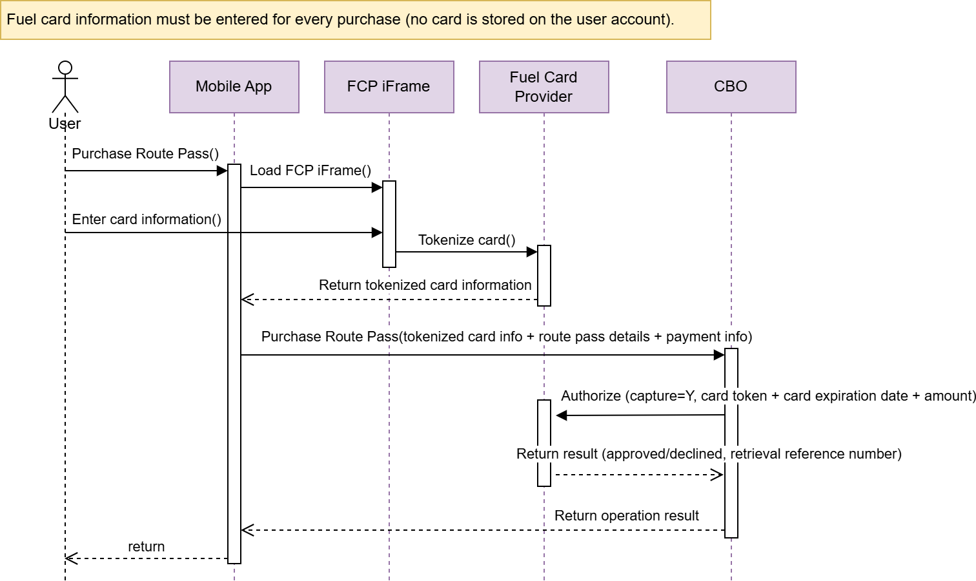

Registration of a fuel card as a payment method for registered users

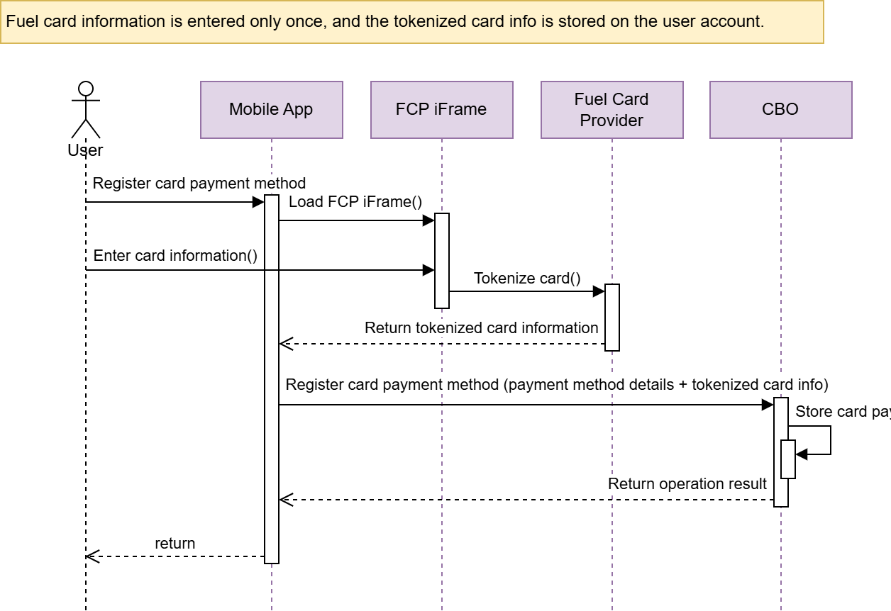

Payment of a Route Pass by a registered user with post-pay account

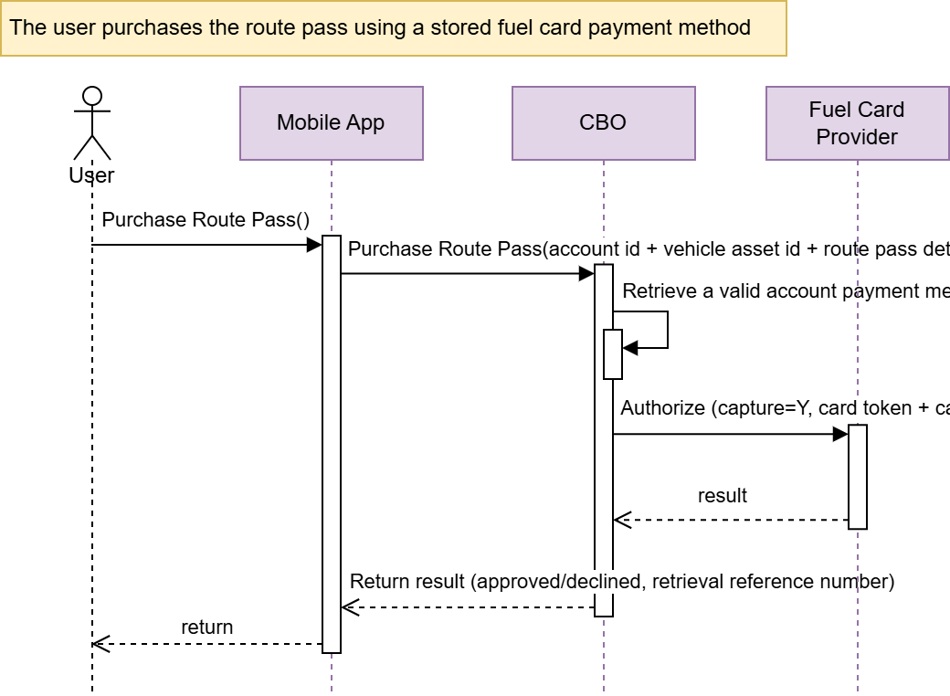

Start a trip by a registered user with post-pay account- Fee Reservation

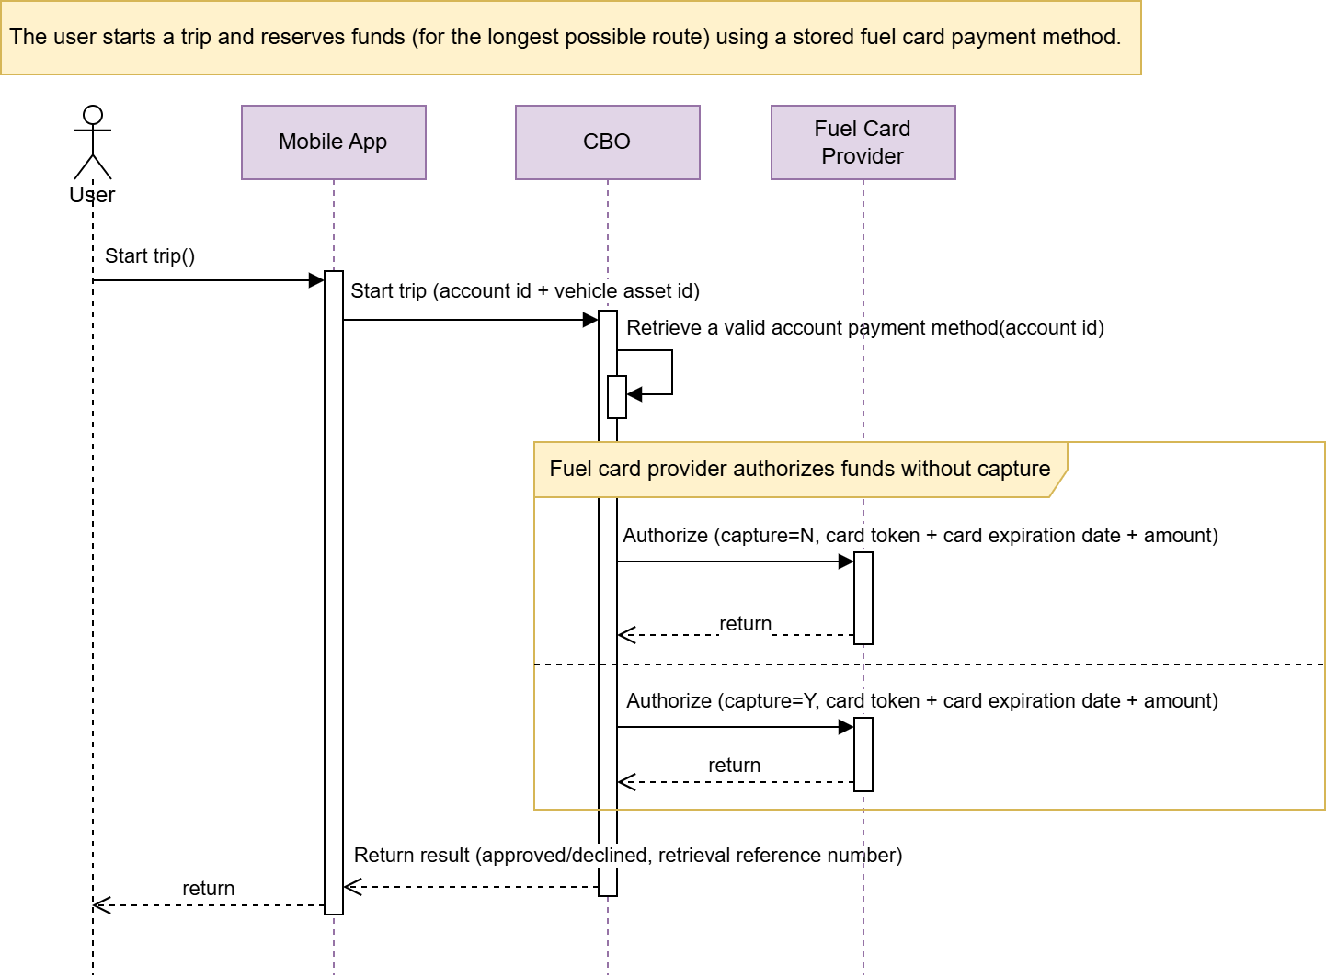

End trip by a registered user with post-pay account

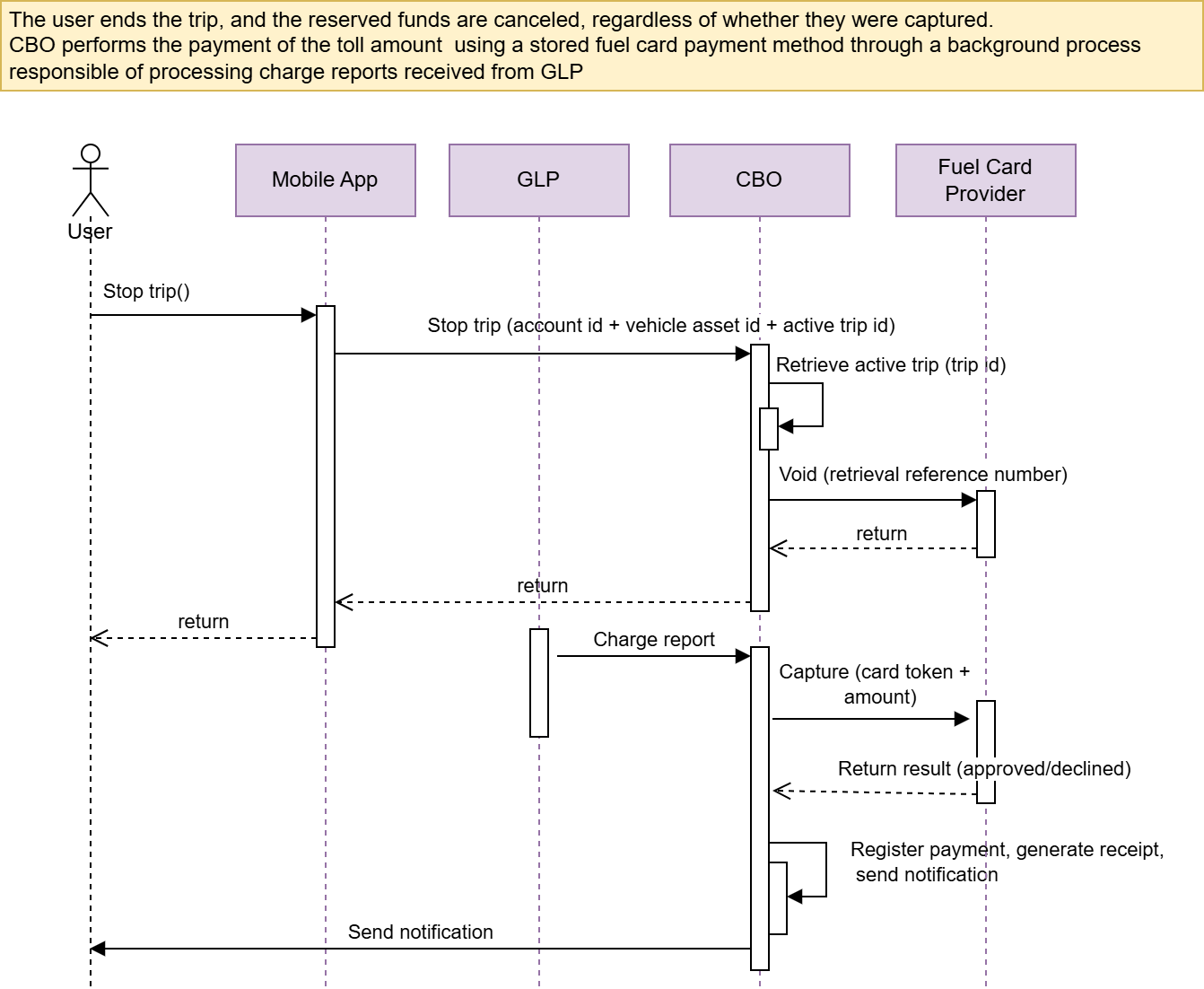

- END OF DOCUMENT -

