LTU Nationwide GNSS Tolling System
EETS Integration Guide
Doc No. 30006
Version 1.1

Author | Paul Litzinger
Reviewed: | Roman Trinko
Approved by: | Hans Gidoff

Overview of changes.
No. | Version | Status | Date | Contributor | Type of the change
1 | 0.1 | Draft | 17.4.2026 | Paul Litzinger | First Version
2 | 1.0 | Released | 20.04.2026 | Paul Litzinger | Released version
3 | 1.1 | Released | 12.06.2026 | Paul Litzinger | Updated based on comments from TSPs
Table 1 Overview of changes

Reference to the status, versions and data classification.
Status:
Draft | the document is being processed
Released | the document has been checked and released, it can only be modified if the version number is updated.
Obsolete | the document is not valid anymore
Versions:
0.1, 0.2 | draft versions
1.0 | first released version with the status “Released“
1.1, 1.2, etc. | draft versions, that supplement version 1.0
2.0 | second released version with the status “Released”
Data classification
Public |  | No restriction
Internal |  | Restricted to internal and external Kapsch employees
Confidential |  | Restricted to selected active directory and/or sharepoint groups (default)
Secret |  | Restricted to selected employees, server encryption needed

Page
Table of Contents
1 Purpose 6
2 Data exchange 7
2.1 Message Exchange 7
2.1.1 General message considerations 8
2.2 Toll declaration 8
2.2.1 Business Context 9
2.2.2 Communication Process 9
2.2.3 Additional Requirements 11
2.3 Billing details 11
2.3.1 Business Context 11
2.3.1.1 Handling of rejected Billing Details 12
2.3.1.1.1 Option: Resend Billing Detail 12
2.3.1.1.2 Option: Adjust Billing Detail 12
2.3.1.1.3 Option: No action needed 12
2.3.2 Communication Process 13
2.3.3 Additional Requirements 16
2.4 Payment claims 16
2.4.1 Business Context 16
2.4.1.1 Handling of rejected Payment Claims 17
2.4.1.1.1 Option: Resend PC 17
2.4.1.1.2 Option: Create PC 17
2.4.1.1.3 Option: No action needed 17
2.4.2 Communication Process 18
2.4.3 Additional Requirements 20
2.5 Exception lists 20
2.5.1 Business Context 20
2.5.2 Communication Process 21
2.5.3 Additional Requirements 23
2.6 Acknowledgements 23
2.6.1 Business Context 23
2.6.2 Communication Process 24
2.6.3 Additional Requirements 24
3 General Requirements, Obligations and Considerations 25
3.1 Security Aspects 25
3.1.1 Trust object exchange 28
3.2 Privacy 28
3.3 General Requirements 29
4 Configurations and Definitions 30
4.1 Specific configurations 30
4.1.1 APCI Object 30
4.1.1.1 Example Message APCI Structure 30
4.1.2 Toll Declaration 32
4.1.2.1 Configurations 32
4.1.2.2 Example Message Structure 33
4.1.3 Billing Detail 36
4.1.3.1 Configurations 36
4.1.3.2 Example Message Structure 36
4.1.4 Payment Claim Configurations 40
4.1.4.1 Example Message Structure 40
4.1.5 Exception List Configurations 41
4.1.5.1 Example Message Structure 41
4.1.6 Acknowledgement Configurations 43
4.1.6.1 Example Message ACK ADU Structure 43

List of Figures
Figure 1 EETS High Level Message Exchange 7
Figure 2 Toll Declaration Exchange 10
Figure 3 EETS BD adjustment process 13
Figure 4 Billing Details Exchange 15
Figure 5 EETS PC adjustment 18
Figure 6 Payment Claims Exchange 20
Figure 7 Exception List Exchange 23
Figure 8 Security Communication Flow 27
Figure 9 Trust Object Exchange 28

List of Tables
Table 1 Overview of changes 2
Table 2 Data Exchanged 7
Table 3 Toll Declaration Timings 11
Table 4 Billing Details Timings 16
Table 5 Payment Claims Timings 21
Table 6 Exception List Timings 24
Table 7 Layered Security Architecture 26
Table 8 EETS APCI object 30
Table 9 EETS TD configurations 32
Table 10 EETS TD object 34
Table 11 EETS BD configurations 36
Table 12 EETS BD object 39
Table 13 EETS PC configurations 40
Table 14 EETS PC object 40
Table 15 EETS EL configurations 42
Table 16 EETS EL object 43
Table 17 EETS ACK object 44

Purpose

This document describes requirements and considerations for EETS Integration, as well as the data objects exchanged between the toll charger and the TSP based on the EFC (Electronic Fee Collection) toolbox standard ISO 12855. The EETS TSPs integrate with the solution based on "Electronic fee collection — Information exchange between service provision and toll charging" ISO 12855:2025(en) standard and corresponding "Electronic fee collection — System architecture for vehicle-related tolling Part 3: Data dictionary" ISO/TS 17573-3:2021 standard. The base ASN.1 specifications are available under ISO 12855 ASN.1 and ISO 17575 ASN.1. Since there is no corresponding released profile ISO 16986 version available at the time of writing this document, the solution aligns on the available draft version. Right to change is reserved.
The document provides a general description of the solution and its configurations. Project specific configurations overrule general aspects and will be defined during the integration process.

Data exchange
The data objects described in this chapter are exchanged between the following two entities:
- Toll Charger (TC), and
- Toll Service Provider (TSP) - also referred to as EETS TSP
The solution distinguishes between two message flows:
- incoming: a request is sent from EETS TSP to the TC
- outgoing: a request is sent form the TC to any EETS TSP
In line with the ISO standard, the data are exchanged based on Info Exchange Messages which contains APCI and ADU Information.

Message Exchange
The messages are exchanged using via a HTTP WebService which exposes and endpoint to which sendAPDU messages are transmitted using the POST method. In line with the ISO 12855 standard, the root object for message exchange is the "infoExchange" object. This object, which is also called Application Protocol Data Unit, contains:
- a single occurrence of Application Protocol Control Information (APCI) object, including information about the sender, receiver, identifier, etc
- one or more Application Data Unit (ADU) objects of the same type.
The following ADUs are supported for automatic exchange via the EETS interface. Details on data objects, formats and value range restrictions are available in the interface specification.
Application Data Object | Direction | Originator | Exchange Mechanism
Exception Lists ADU | incoming | EETS TSP | HTTP WebService
Toll Declarations ADU | incoming | EETS TSP | HTTP WebService
Billing Details ADU | outgoing | TC | HTTP WebService
Payment Claims ADU | outgoing | TC | HTTP WebService
Acknowledgement ADUs | incoming | EETS TSP | HTTP WebService
Acknowledgement ADUs | outgoing | TC | HTTP WebService
Table 2 Data Exchanged
To establish trust between the TC and EETS TSP solution, a trust object ADU needs to be exchanged. This exchange is done manually. Other needed data objects or information that is exchanged manually are userDetails and EFC context data.
The following diagram illustrates the high level message exchange process, including the sending of a message and the asynchronous acknowledgement response. The flow depicted shows an example where the TC receives a message and answers with an acknowledgement ADU, a typical example is the Toll Declaration ADU.

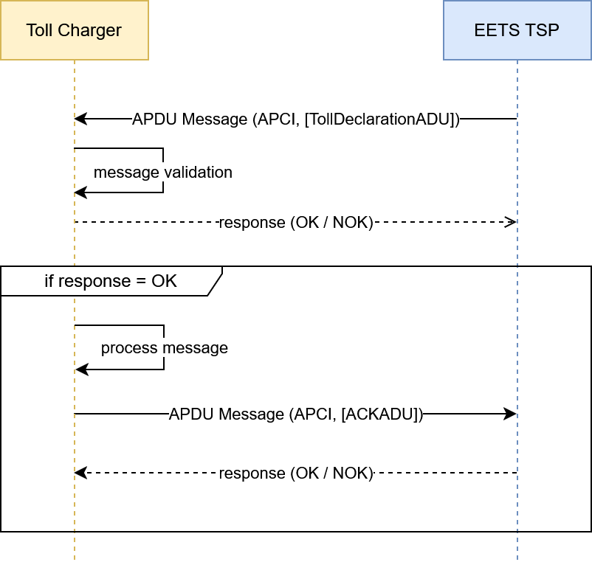
Figure 1 EETS High Level Message Exchange

As depicted, only messages passing message validation process successfully will be further processed by the solution. Therefore, successful transmission of the data is not sufficient for the originator to conclude that the data-sets and are correct according to all business rules and have been accepted by the recipient. The technical acceptance process which is executed asynchronously may detect the violation of a business rule and result in the rejection of the data. Depending on the result of the process, the asynchronous acknowledgement (ACK) ADU will signal business acceptance or rejection of the message. The achnowledgement ADU transmitted in this process contains specific information in case technical errors or warnings have occurred during the processing for the data.

General message considerations
- The solution uses JSON Encoding Rules (JER)
- All reported times are interpreted in generalized time and in UTC +/- 0. The required format is "YYYYMMDDHHmmssZ".
- In case of a transmission error (e.g.: TSP system is unavailable) the systems retry to send the message. In case the message cannot be delivered for an extended period of time, the receiving entity shall be informed and further steps shall be mutually agreed.
The following chapters describe the different Application Data Unit types in detail.

Toll declaration
This section describes the process and requirements for Toll Declaration exchange.

Business Context
The collection process uses a GNSS device to record the location information. A GNSS device is a single device, capable of recording GNSS location information and transmitting them to the central tolling system. The GNSS device is mounted inside a toll liable vehicle to record the vehicles movement. The GNSS device records the locations (i.e., GNSS positions) of the vehicle according to defined and configurable frequency - position storing interval - (e.g., every 5 seconds) when inside the charging relevant area - toll domain area . For each position, the GNSS device records the following information to fulfill solutions needs:
- longitude,
- latitude,
- altitude (optional),
- date and time, and
- the following quality parameters:
- speed
- course
- horizontal accuracy
Optionally, the devices may implement a stand still filter, to prevent the collection of position clouds in congestion situations or while the vehicle is waiting at a red light. The collected location information is enriched with charging relevant vehicle attributes and aggregated according to the defined and configurable aggregation period - position reporting frequency - (e.g., 5 minutes). The charging relevant vehicle attributes are a toll domain specific set and may vary between toll domains based on the used tariff table. Amongst others, the solution supports the following typical attributes:
- Vehicle class: according to Vehicle registration documents
- Vehicle axles: tractor and trailer axles according to vehicle registration documents and current vehicle train configuration
- Vehicle weight limits: according to vehicle registration documents
- Euro class: according to vehicle registration document
- CO2 emission class: according to the EU scheme of CO2 emission classes based on vehicle registration documents
To identify the vehicle and the device used for collection, the packaged position data are attributed with following identifiers:
- License plate number: the country code and LPN according to vehicle registration documents
- Device identifier: the unique identifier of the the GNSS device used to record the location information, composed of provider, manufacturer and equipment identifier
The resulting position package is transmitted to the central tolling system for the detection of the use of toll liable roads and the calculation of the related toll charges.

Communication Process
The charging process starts with the collection of position packages by the OBE as previously described. Those position packages are received from OBEs by their contracted EETS TSP. The EETS TSP generates Toll Declaration ADUs and transmits them to the TC. The solution receives Toll Declaration ADUs (TD ADUs), packaged in Info Exchange messages in the agreed aggregation level (maximum number of TD ADUs), from accredited EETS TSP. After successful syntactical and semantic validation of the TD ADUs, the solution response with an asynchronous Acknowledgement ADU (ACK ADU), confirming the reception and successful processing of all provided TD ADUs. In case errors are encountered during validation, the solution rejects individual TD ADUs with a meaningful error code. The validations performed include but are not limited to:
- Syntactical correctness (Error code: apduNotOk)
- Syntactical correctness on TD ADU (Error code: apduNotOk)
- Duplicate transmission of TS ADUs (Error code: tollDeclarationDuplicateTollDeclarationRejected)
Internal errors can be caused by too large messages (e.g.: list of TD ADUs in a request was outside agreed value range). Only successfully acknowledge TD ADUs will be subject to charge evaluation. The exchange follows the communication and timings as defined in ISO 16986.
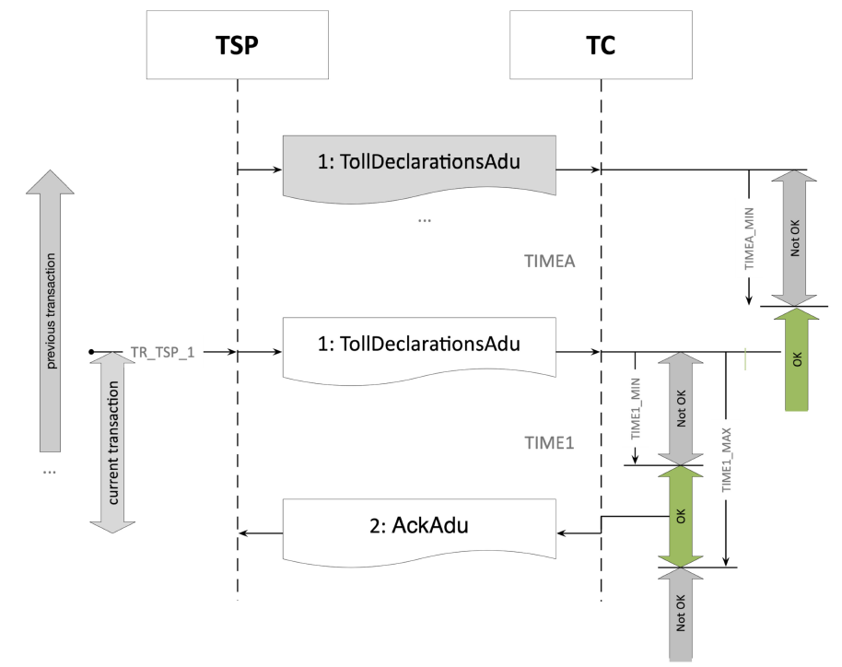
Figure 2 Toll Declaration Exchange
With the following configurable timings:
Trigger/Timing | Meaning | Default
TR_TSP_1 | A TSP may initiate a TOLLDECLARATION_SECT transaction at any time after TIMEA_MIN. | Default = 30 minutes, according to the agreed reporting interval per OBE
TIMEA_MIN | The minimum time between the sending of two TollDeclarationAdus in two consecutive TOLLDECLARATION_SECT transactions. | Default = 0 seconds to allow for list of TD ADUs
TIME1_MIN | The minimum time required by the TC to acknowledge the received toll declaration by sending an ACK ADU. | Default = 0 seconds to allow of immediate rejection in syntax error case
TIME1_MAX | The maximum time allowed to the TC to acknowledge the received toll declaration by sending an ACK ADU. | Default = 24 h. To take into account operational procedures in case of maintenance or unplanned downtime. In normal operations the response should be within a few (10) seconds.
Table 3 Toll Declaration Timings

Additional Requirements
- Toll Declaration ADUs shall be transmitted in a way that position sequence is chronologically ascending.
- Every transmitted and positively acknowledged TD ADU is subject to charging. The solution does not evaluate the corresponding user exception list entry.
- An APDU containing TD ADUs, which is fully or partially rejected by an ACK ADU must not be re-sent. It is expected that the EETS TSP creates a new APDU containing corrected TD ADUs to allow processing.
- Processing of Toll Declaration data containing future GNSS time stamps is not supported. Such TDs will be acknowledged by the solution and silently discarded by the map matching process.
- The solution adheres to the data minimization principle. The solution receives as input vehicle characteristics. Only charging relevant vehicle characteristics are needed by the solution to process the charge. However the ISO 12855 standard structure demands the transmission of no charging relevant vehicle characteristics. For example: data object Axles requires the transmission of axle height, tire type, tractor and trailer axles. For a toll domain not all information included in the axles object is required, for example only tractor and trailer axles could be rating relevant. The solution expects to receive all mandatory fields but ignores values that are not charging relevant.

Billing details
This section describes the process and requirements for Billing Details exchange.

Business Context
The solution identifies tolled road usage for the received TD ADUs using a map matching process employing a gap closing algorithm. The resulted charges are grouped into single aggregated tariff classes, which are the base for Billing Detail creation. The Billing Details are created by the solution on user level and based on a configurable aggregation interval (billing detail aggregation period). During aggregation, the solution groups all detected charge objects into single tariff class sessions. In case a use is subject to different tariff classes within the billing detail aggregation period, the system will create one billing detail per distinct tariff class. A billing detail contains the following information for each user:
- Period: the begin and end equal to billing detail aggregation period
- Billing detail amount
- Identified tariff
- Vehicle description
- External costs
- Array of used sections with corresponding identifiers and used distance
The Billing Details are issued on user level and as such they are the base for user invoicing. The Billing Details are expected to be accepted or rejected by the EETS TSP. Only accepted Billing Details will be further processed. In case of Billing Detail rejection, an operations process is followed. During bilateral discussion and after reaching an agreement a new billing detail will be issued with corrected amount and referencing the billing detail subject to initial rejection.

Handling of rejected Billing Details
To support the operational handling of rejected Billing Details, the solution allows the creation of a new Billing Details by an authorized agent based on an existing Billing Detail.
The process offers three possibilities for managing negatively acknowledged BDs:

Option: Resend Billing Detail
This option is primarily intended for cases where a Billing Detail was negatively acknowledged due to a timeout or another technical issue on the TSP side.
In this case, the Billing Detail is re-sent unchanged, except for the assignment of a new Billing Detail identifier.

Option: Adjust Billing Detail
This option is primarily intended for cases where the TSP reports a claim or issue concerning the content of the Billing Detail and where bilateral clarification results in an agreed correction.
In this case, the solution uses a dedicated Billing Detail structure intended for the registration of adjustments. The adjusted Billing Detail uses the fee text detail option instead of the original usage list entry for sectioned roads. It shall contain the original Billing Details Identifier as a reference.
The new BD contains an agreed amount and free text detail information reflecting the agreement. The BD will be sent in the next suitable sending time slot. It is expected that BDs of such type are not rejected by TSPs.

Option: No action needed
If the outcome of the bilateral clarification is that no new Billing Detail is required, no correction is created and no further action is initiated.

The following diagram visualizes the process.

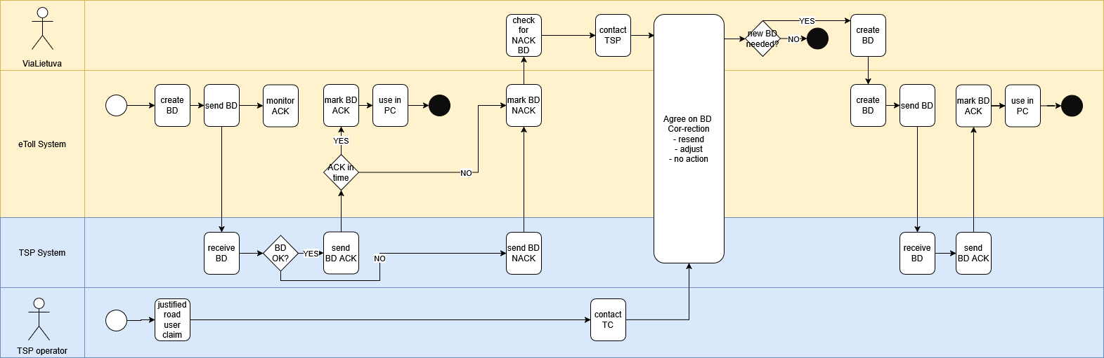
Figure 3 EETS BD adjustment process

Communication Process
The created Billing Details are sent to the EETS TSP as Billing Details ADU upon completion. The EETS TSP validates the Billing Details and signals acceptance or rejection in ACK ADUs. Only positively accepted Billing Details will be subject to further processing. Rejected Billing Details are reported to the operations team and are clarified with EETS TSP. In case of rejection of a BillingDetail, the TSP informs the reason of the rejection. Irrespective of the reason, the Billing Detail is considered rejected and needs to be clarified with the TSP. The following reasons and related codes are supported by the solution:
- billingDetailsIssuerIdRejected: code 700
- billingDetailsRejected: code 701
- billingDetailsTollContextOperatorMismatch: code 702
- billingDetailsTollContextOperatorRejected: code 703
- billingDetailsUserIdRejected: code 704
- billingDetailsPeriodRejected: code 705
- billingDetailsAmountRejected: code 706
- billingDetailsUserIdLpnMissing: code 719
- billingDetailsUserIdLpnNotResponsible: code 720
- billingDetailsUserIdObeIdMissing: code 724
- billingDetailsPeriodMissing: code 730
- billingDetailsContentDupicate: code 735
The following reason codes are not supported by the solution.
- billingDetailsContextNameRejected: code 707
- billingDetailsAppliedUserClassRejected: code 708
- billingDetailsAppliedLocalVehicleClassRejected: code 709
- billingDetailsAppliedTimeClassRejected: code 710
- billingDetailsEntryTimeRejected: code 711
- billingDetailsEntryChargeObjectRejected: code 712
- billingDetailsEntryLocationClassRejected: code 713
- billingDetailsExitChargeObjectRejected: code 714
- billingDetailsExitTimeRejected: code 715
- billingDetailsReferenceRejected: code 716
- billingDetailsExitLocationClassRejected: code 717
- billingDetailsBillingDetailsInfoNotSupported: code 718
- billingDetailsUserIdPanMissing: code 721
- billingDetailsUserIdPanNotValid: code 722
- billingDetailsUserIdPanNotAllowed: code 723
- billingDetailsUserIdEfcContextMarkMissing: code 725
- billingDetailsUserIdEfcContextMarkNotAllowed: code 726
- billingDetailsPaymentMeansIgnored: code 727
- billingDetailsRelatedBillingDetailsUnknown: code 728
- billingDetailsRelatedBillingDetailsInfoNotSupported: code 729
- billingDetailsAmountIgnored: code 731
- billingDetailsRefTollDeclarationIgnored: code 732
- billingDetailsRefTollDeclarationUnknown: code 733
- billingDetailsRefTollDeclarationIdNotSupported: code 734
The exchange follows the triggers and timing as defined in ISO 16986
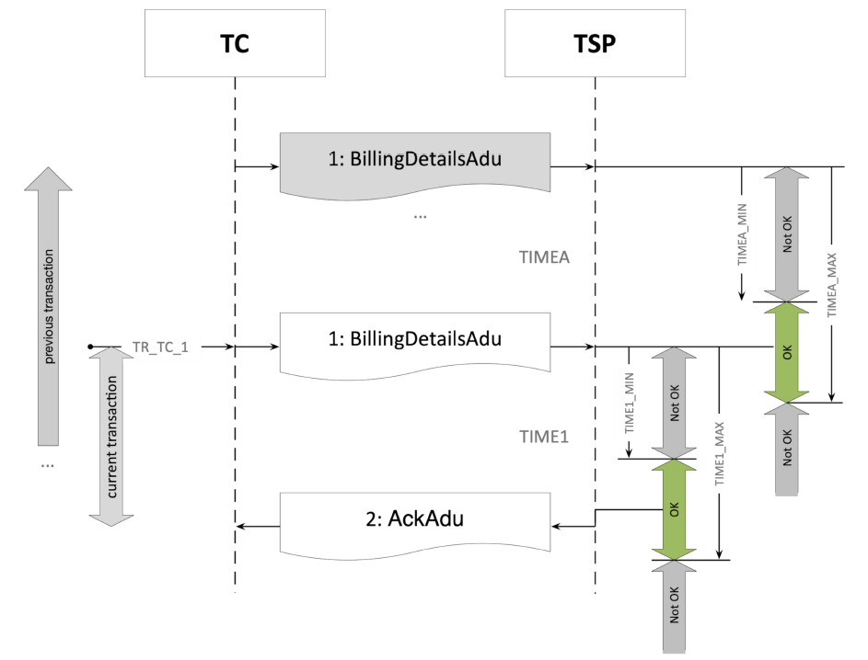
Figure 4 Billing Details Exchange
With the following configurable timings
Trigger/Timing | Meaning | Default
TR_TC_1 | A TC shall initiate a BILLINGDETAILS_TC at any time in the interval between TIMEA_MIN and TIMEA_MAX. | according to grouping time, default BD creation starts at 01:00:00 covering the charges of the previous period.
TIMEA | The time between the sending of two BillingDetailsAdus in two consecutive BILLINGDETAILS_TC transactions. | Default = 0 seconds, to allow list of BD ADUs
TIMEA_MIN | The time between the sending of two BillingDetailsAdus in two consecutive BILLINGDETAILS_TC transactions. | Default = 0 seconds, to allow list of BD ADUs
TIMEA_MAX | The maximum time for sending of two BillingDetailsAdus in two consecutive BILLINGDETAILS_TC transactions | Default = 24 hours, to allow for interfering of operations due to planned or unplanned interruptions
TIME1_MIN | The minimum time required by the TSP to acknowledge the BillingDetailsAdu by sending an AckAdu. | Default = 0 seconds, to allow of immediate rejection in syntax error case
TIME1_MAX | The maximum time allowed to the TSP to acknowledge the BillingDetailsAdu by sending an AckAdu. | Default = 6 hours, to ensure that the processing of AckAdu can be completed before the next cycle
Table 4 Billing Details Timings
Billing Detail which are not acknowledged within the agreed timings are considered as rejected by the solution. Delayed transmission of ACK ADUs are rejected by the solution.

Additional Requirements
The solution adheres to data minimization principle. This means that only charging relevant vehicle characteristics will be returned in the Billing Details vehicle description. All other fields demanded mandatory by the standard will include default values as defined in the configuration section.

Payment claims
This section describes the process and requirements for Payment Claims exchange.

Business Context
The final stage of the EETS charging process is to issue Payment Claims. Similar to Billing details which group usage statements, th solution groups Billing Details into Payment Claims on a configurable periodicity. Only positively acknowledged Billing Details will be grouped. The grouping is subject to configurable business rules, such as grouping by time, grouping by maximum number of Billing Details, etc.
The following grouping is default:
- payment claim aggregation period: default 30 days (1st day of the month at 00:00:00 to last day of the month at 23:59:59) (global configurable value)
- maximum number of billing details: default 5000 (global configurable value) to restrict the maximum size of a payment claim
As payment claims are not grouped on user level, they contain the following minimum information:
- total amount
- aggregation start and end
- referencing the acknowledged billing details as ReferencedAduIdentifier.
In general, it is not expected that Payment Claims are rejected, as they include only acknowledged Billing Details. In case of Payment Claim rejection, an operations process is followed. During bilateral discussion and after reaching an agreement, a new Payment Claim will be issued with the corrected amount and referencing the payment claim subject to initial rejection.
All positively acknowledged Payment Claims will be subject to payment by the EETS TSP.

Handling of rejected Payment Claims
For Payment Claims the process of managing rejected Payment Claims is similar to Billing Details. Like BD process the PC claim process will result in the creation of a new PC. The solution supports agent with sufficient rights in the management of new Payment Claims.
The process offers three possibilities for managing negatively acknowledged PCs:

Option: Resend PC
This option is primarily used in case the PC were not acknowledged due to time out of the TSP. In this option the PC is re-sent unaltered but with a new PC identifier.

Option: Create PC
The solution manages an audit trail to trace manual BD and PC creation process. The solution ensures that any newly created Billing Detail (BD) or Payment Claim (PC), is based on an existing BD or PC and maintains a internal reference to the originating BD/PC.
This option is primarily intended for cases where the TSP reports a claim or issue concerning the content of the Payment Claim and where bilateral clarification results in an agreed correction.
In this case, the solution uses a dedicated Payment Claim structure intended for the registration of adjustments. The adjusted Payment Claim uses the paymentClaimDetails structure.
The new PC contains an agreed amount and paymentDetailText reflecting the agreement. The PC will be sent in the next suitable sending time slot. It is expected that PCs of such type are not rejected by TSPs.

Option: No action needed
If the outcome of the bilateral clarification is that no new PC is required, no correction is created and no further action is initiated.

The following diagram visualizes the process.

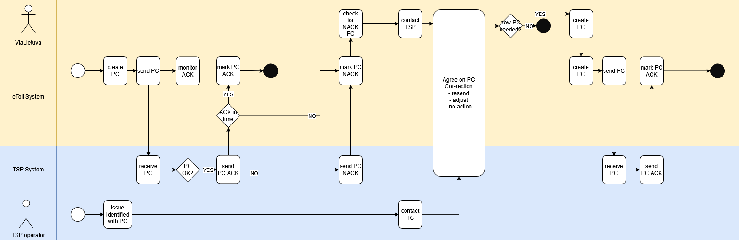
Figure 5 EETS PC adjustment

Communication Process
The created Payment Claims are sent to the relevant EETS TSP as Payment Claims ADU in the agreed frequency and aggregation. The EETS TSP validates the Payment Claims and signals acceptance or rejection in ACK ADUs. Only positively accepted Payment Claims will be subject to further processing (invoice generation, etc). Rejected Payment Claims are reported to the operations team and are clarified with EETS TSP. The timings presented are considered configurations and might change according to the needs of the solution, for example due to performance considerations. It is expected that the TSP solution can adapt to the changes required. Payment Claims which are not acknowledged within the agreed timings are considered as rejected by the solution. Delayed transmission of ACK ADUs are rejected by the solution.
In case of rejection of a Payment Claim, the TSP informs the reason of the rejection. Irrespective of the reason, the Payment Claim is considered as rejected and needs to be clarified with the TSP. The following reasons are supported by the solution:
- claimRejectedByTsp: code 800
- paymentClaimIdRejected: code 802
- paymentClaimStartDateTimeRejected: code 803
- paymentClaimEndDateTimeRejected: code 804
- paymentClaimUserIdRejected: code 805
- paymentClaimPaymentClaimAmountRejected: code 806
- paymentClaimPaymentClaimStatusRejected: code 807
- paymentClaimTypeOfContentRejected: code 808
- paymentClaimEndDateTimeMissing: code 809
- paymentClaimStartAndEndDateTimeInvalid: code 810
- paymentClaimUserIdMismatch: code 812
- paymentClaimUserIdUnknown: code 813
- paymentClaimUserIdBlocked: code 814
- paymentClaimUserIdNotSupported: code 815
- paymentClaimUserIdMissingForCreditNote: code 816
- paymentClaimPaymentClaimAmountMismatch: code 817
- paymentClaimPaymentClaimStatusNotSupported: code 818
- paymentClaimTypeOfContentMissing: code 819
- paymentClaimTypeOfContentNotSupported: code 820
- paymentClaimReferenceDetailListMismatch: code 822
- paymentClaimDetailsPaymentDetailTypeMissing: code 828
- paymentClaimDetailsPaymentDetailTypeNotSupported: code 829
- paymentClaimDetailsPaymentDetailTextMissing: code 830
- paymentClaimDetailsPaymentDetailQuantityMissing: code 831
- paymentClaimDetailsPaymentDetailQuantityNotSupported: code 832
- paymentClaimDetailsPaymentDetailDiscountMissing: code 833
- paymentClaimDetailsPaymentDetailBasicAmountMissing: code 834
- paymentClaimDetailsPaymentDetailBasicAmountMismatch: code 835
- paymentClaimDetailsPaymentDetailAmountExclVatMissing: code 836
- paymentClaimDetailsPaymentDetailAmountExclVatMismatch: code 837
- paymentClaimDetailsPaymentDetailAmountTotalMissing: code 838
- paymentClaimDetailsPaymentDetailAmountTotalMismatch: code 839
The following reason codes are not supported by the solution.
- paymentClaimUserIdMissingForClaim: code 811
- paymentClaimReferenceDetailListMissing: code 821
- paymentClaimReferenceDetailListIgnored: code 823
- paymentClaimPaymentReferenceIgnored: code 824
- paymentClaimPaymentClaimDetailsIgnored: code 825
- paymentClaimDetailsPaymentDetailCodeIgnored: code 826
- paymentClaimDetailsPaymentDetailNumberIgnored: code 827
The exchange follows the communication and timings as defined in ISO 16986
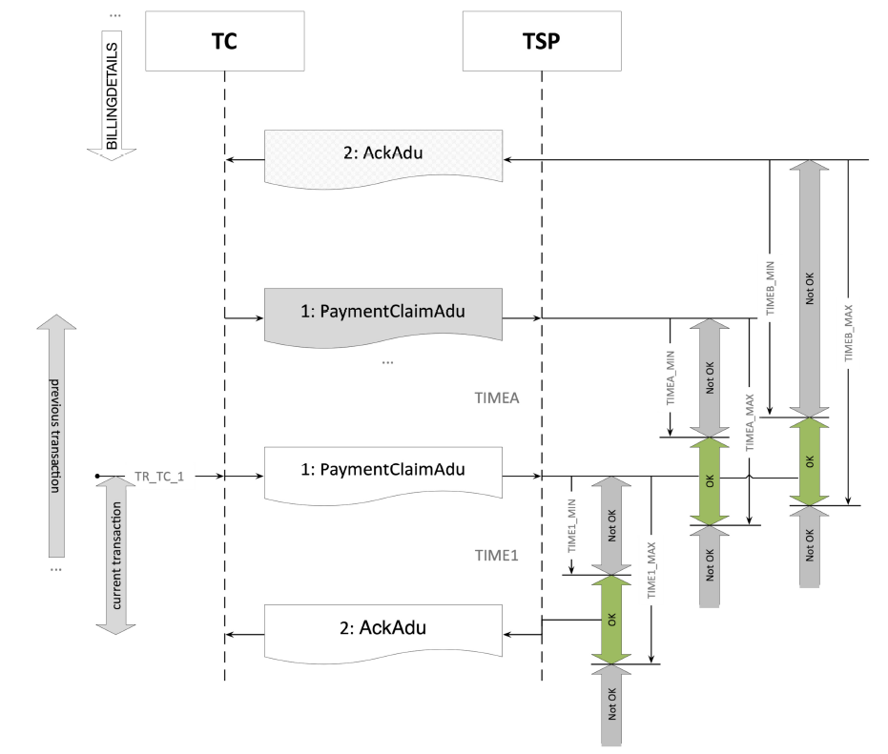
Figure 6 Payment Claims Exchange
With the following timings:
Trigger/Timing | Meaning | Default
TR_TC_1 | A PAYMENTCLAIM transaction shall be initiated within the intersection of the time interval between TIMEA_MIN and TIMEA_MAX with the time interval between TIMEB_MIN and TIMEB_MAX. | The payment Claim will be sent within a configurable time period of the grouping interval  according to grouping time, default PC creation starts at 01:00:00 covering the charges of the previous period
TIMEA_MIN | The minimum time between the sending of two PaymentClaimAdus in two consecutive PAYMENTCLAIM transactions | Default = 0 seconds, to enable sending a list of Payment Claims
TIMEA_MAX | The maximum time between the sending of two PaymentClaimAdus in two consecutive PAYMENTCLAIM transactions | Default = 20 days, to account for outages and clarifications of not acknowledged Billing details
TIMEB_MIN | The minimum time between the sending of a PaymentClaimAdu in a PAYMENTCLAIM transaction and AckAdu in the corresponding BILLINGDETAILS transaction. | Default = 0 min, to enable same day issuing of Payment Claims
TIMEB_MAX | The maximum time between the sending of a PaymentClaimAdu in a PAYMENTCLAIM transaction and AckAdu in the BILLINGDETAILS transaction transferring a BillingDetailsAdu referenced in the PaymentClaimAdu. | Default = 20 days, to account for outages and clarifications of not acknowledged Billing details
TIME1_MIN | The minimum time required to acknowledge the received PaymentClaimAdu in a PAYMENTCLAIM transaction. | Default = 0 seconds, to allow of immediate rejection in syntax error case
TIME1_MAX | The maximum time required to acknowledge the received PaymentClaimAdu in a PAYMENTCLAIM transaction. | Default = 6 hours, to ensure that the processing of AckAdu can be completed before the next cycle
Table 5 Payment Claims Timings

Additional Requirements
No additional requirements

Exception lists
This section describes the process and requirements for Billing Details exchange.

Business Context
EETS TSP lists are used to support the enforcement process or to identify EETS TSPs which shall be notified in case a business process demands a notification. TSP lists are exchanged in accordance with the ISO12855:2025 message structure. Due to the expected list size of TSP Lists, full lists are only exchanged during night times. The system supports the following list types:
- Access list: A list containing all users the TSP has a contract with and for which the TSP guarantees toll payment. The LPN is a mandatory data field in this list. The access list needs to be accessible for business process.
- Block list: A list containing all users the TSP has a contract with, but for which the guarantee for toll payment has temporarily been suspended. The LPN is a mandatory data field in this list. A user can only be removed from a block list explicitly (not via adding to the access list).
Block and access list are not mutually exclusive. The system supports only full list exchange. To limit the size of the lists, only the following minimal information is exchanged:
- list type
- list version: needs to be incremented, is unique in combination with list type
- list validity start
- for each list entry:
- License Plate Number
- Obe identifier
- Payment Means (mandatory due to profile)
- reason: for access lists only reason 8 (user on access list) is supported.
A user on a list is considered to be on the list until the user is removed from the list at the next possible list exchange.

Communication Process
The list exchange process starts with the exchange Exception List (EL) ADUs compiled by the EETS TSP. The system receives Exception List ADUs packaged in Info Exchange messages transmitted at agreed time window (full exception list exchange window) from accredited EETS TSP. Due to the expected EL size, the system only allows the transmission of one EL ADU within an Info Exchange message. Additionally, EL ADUs are discriminated by exception list type. Only one EL type can be exchanged at a time (for example Access Full List or Block Full List). After successful syntactical and semantic validation of the EL ADUs, the system response with an asynchronous Acknowledgement ADU confirming the reception and processing of the EL ADU. In case of errors encountered during validation, the system rejects the EL ADU with a meaningful error code.
The validations performed include but are not limited to:
- syntax error (apduNotOk)
- syntax error on EL ADU (apduNotOk)
- exception list type rejected, rejection reason code 401
Only successfully acknowledge EL ADUs will be subject to charge evaluation. The exchange follows the communication and timings as defined in ISO 16986.
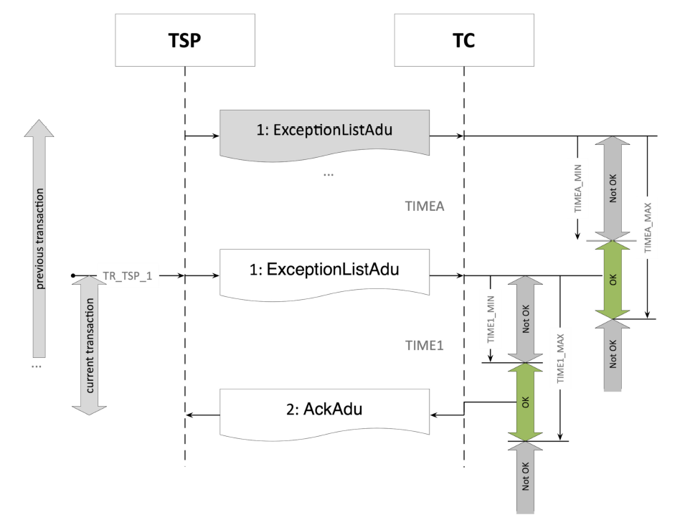
Figure 7 Exception List Exchange
With the following timings
Trigger/Timing | Meaning | Default
TR_TSP_1 | This trigger shall be initiated within the time interval defined by TIMEA_MIN and TIMEA_MAX.
TIMEA_MIN | The minimum time between sending of two ExceptionListAdus in two consecutive EXCEPTIONSLIST transactions | Default = 10 minutes
TIMEA_MAX | The maximum time allowed between sending an ExceptionListAdu in two consecutive EXCEPTIONLIST transactions. | Default = 300 minutes, constraint by the full exception list exchange window
TIME1_MIN | The minimum time required to acknowledge the provided ExceptionListAdu by sending an AckAdu. | Default = 0 seconds to allow of immediate rejection in syntax error case
TIME1_MAX | The maximum time allowed to acknowledge the provided ExceptionListAdu by sending an AckAdu. | Default = 24 h. To take into account operational procedures in case of maintenance or unplanned downtime. In normal operations the response should be within a few (10) seconds.
Table 6 Exception List Timings

Additional Requirements
- In case a user is on the block list, the EETS TSP is expected to not send Toll Declaration ADUs for this user as long as the user is on the block list.
- In case a user is on the access list, the EETS TSP is expected to send Toll Declaration ADUs, unless the user is included in the block list as well.
- The solution expects that each entry on a list is already valid, thus validity start needs to indicate now or a value in the past. In case the validity start of the list is in the past, the system considers it to be active with the data and time of reception.
- In case a not expected reason is provided as reason code, the system assumes that the reason code is erroneous but accepts the list entry.
- In case a EL ADU could not be successfully exchanged during the full exception list exchange window the iteration of EL exchange is skipped. Note: This is possible as the successful exchange of the list is not influencing the charging behavior.
- The EETS TSP is responsible to keep the lists up to date in accordance with the allowed update interval.

Acknowledgements
This section describes the process and requirements for Acknowledgement exchange.

Business Context
The solution exchanges Acknowledgements (ACK) ADUs in order to complete a business process. The ACK ADUs contain the business information about the acceptance or rejection of the referenced ADU. The ACK ADU is can be used to signal complete acceptance or rejection of an entire APDU or to inform only individual ADU(s) rejection, providing additional reasons. In general the following logic holds:
Field | Value and Usage
apduAckCode | - If the apduAckCode is apduOk, and the issues structure is omitted, or transported empty, then all ADUs are accepted.  - If the apduAckCode is apduOK, but the issues structure is present, and it contains issues, then the issues listed with an issueCode are rejected.  - If the apduAckCode is not apduOK then the whole message is rejected, including all of its ADUs.
issues | this object identifies the specific ADU identifiers in case of partial rejection.
issueCode | Must be set to one of the values as supported in the corresponding business context

Communication Process
The communication of Ack ADUs can be triggered by both parties, TC and EETS TSP. Whoever creates the ACK ADUs sends it immediately to the receiving entity. In line with ISO 16986 profile no timings or trigger restrictions are specified.

Additional Requirements
No additional requirements

General Requirements, Obligations and Considerations
This section describes general requirements and obligations that EETS TSPs are expected to fulfill as well as considerations EETS TSPs need to take into account.

Security Aspects
The following table gives an overview of the layered scurity setup:
Layer | What It Protects | When It Protects | Why It Matters
TLS | Transport confidentiality & integrity | During every request | Prevents eavesdropping and tampering in transit
OAuth 2.0 +ClientId + Client Secret | Client authentication | When requesting tokens | Ensures only trusted clients can obtain JWTs
JWT Access Token | Authorization & identity | On every API call | Enforces permissions and validates caller identity
Refresh Token | Session continuity | When access token expires | Enables long sessions without exposing API key
Payload Signing | Message integrity | On every signed request | Ensures payload cannot be altered without detection
Table 7 Layered Security Architecture
When a client interacts with the system, security is enforced in layered stages. Each mechanism protects a different part of the communication flow. TLS provides encrypted transport so data cannot be intercepted or modified in transit. The identity verification step happens when the client presents its client Id and secret to the OAuth 2.0 token endpoint, prooving it is an authorized application and receiving a short‑lived JWT in return. The JWT then becomes the client’s access token for executing business needs. JWT being validated on every request to ensure the caller is authenticated and authorized. JWTs expire quickly to limit exposure, refresh tokens allow the client to obtain new access tokens without repeatedly presenting the API key. Finally, payload signing adds message‑level integrity: the client signs the request body with its private key, and the system verifies the signature using the corresponding public key, ensuring the payload itself has not been altered. Together, these layers form a defense‑in‑depth model that secures the transport, authenticates the client, authorizes each request, maintains long‑lived sessions safely, and guarantees that the payload remains intact.
- TLS Protects the transport channel by encrypting data in transit and ensuring the client is talking to the legitimate server. It prevents eavesdropping and tampering during transmission but does not authenticate the client or authorize API access.
- OAuth 2.0 + clientId and secret Protects the token issuance stage. The API key identifies the client application and allows it to obtain a JWT. This ensures only registered and trusted clients can request tokens.
- JWT Access Token Protects each API request. The JWT carries identity and authorization claims and is validated by your API gateway or backend on every call. It ensures the caller is authenticated and allowed to perform the requested action.
- Refresh Token Protects session continuity. It allows the client to obtain new access tokens without repeatedly exposing the API key. This reduces risk while enabling long‑lived sessions.
- Payload Signing Protects message integrity. The client signs the payload with its private key, and the server verifies the signature using the client’s public key. This ensures the payload has not been altered, even if the transport layer is secure.
The following diagram gives an overview of the security setup.

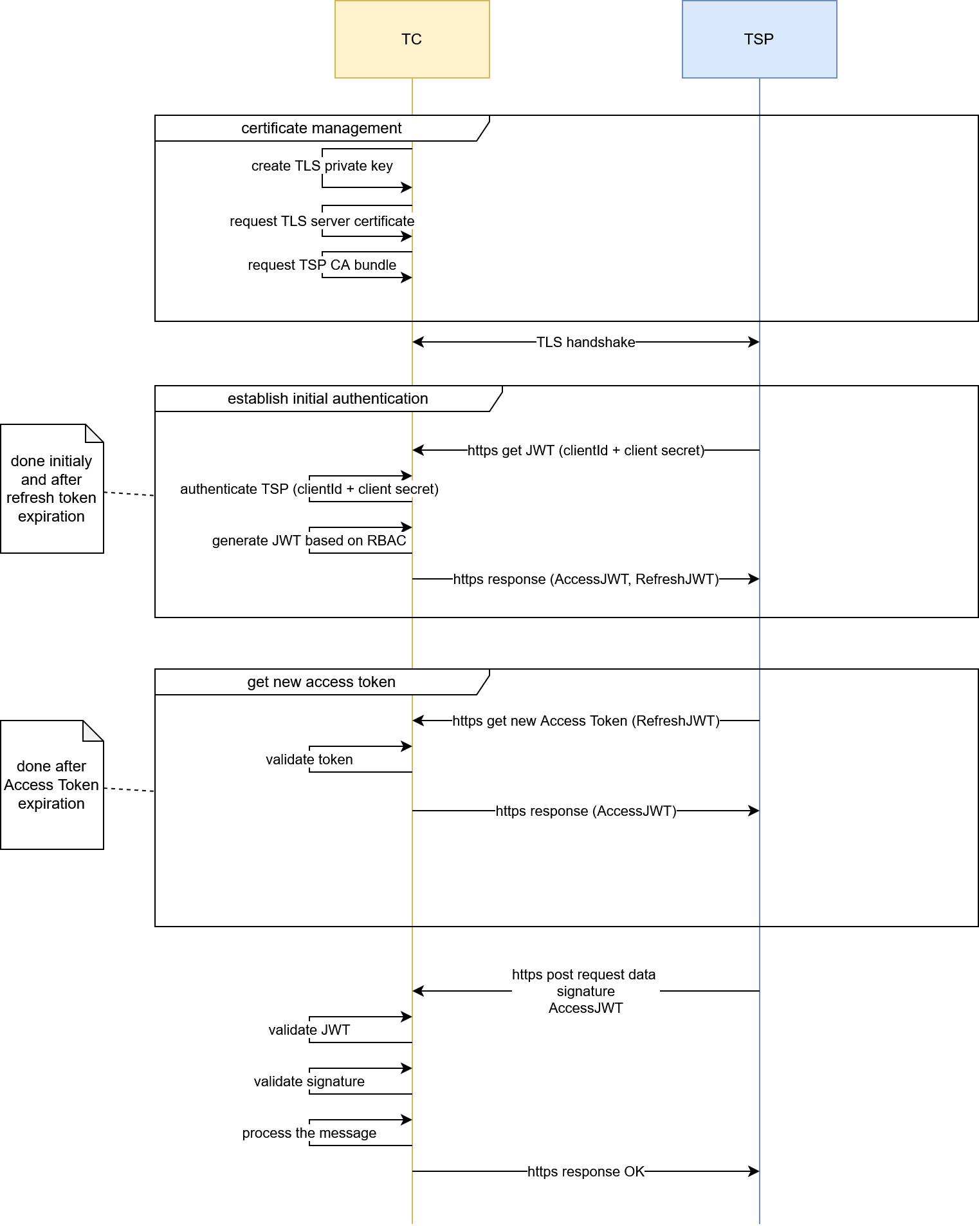
Figure 8 Security Communication Flow

The selected security architecture represents a state of the art architecture for IT systems. In case new threats are discovered or other requirements require the update of the security schemes the clients are obliged to support the updated scheme.

Trust object exchange
The system establishes initial trust by issuing TSP and TC signing and communication certificates and client credentials. Exchange of trust objects is manual and will be done between TC and EETS TSP security officers.

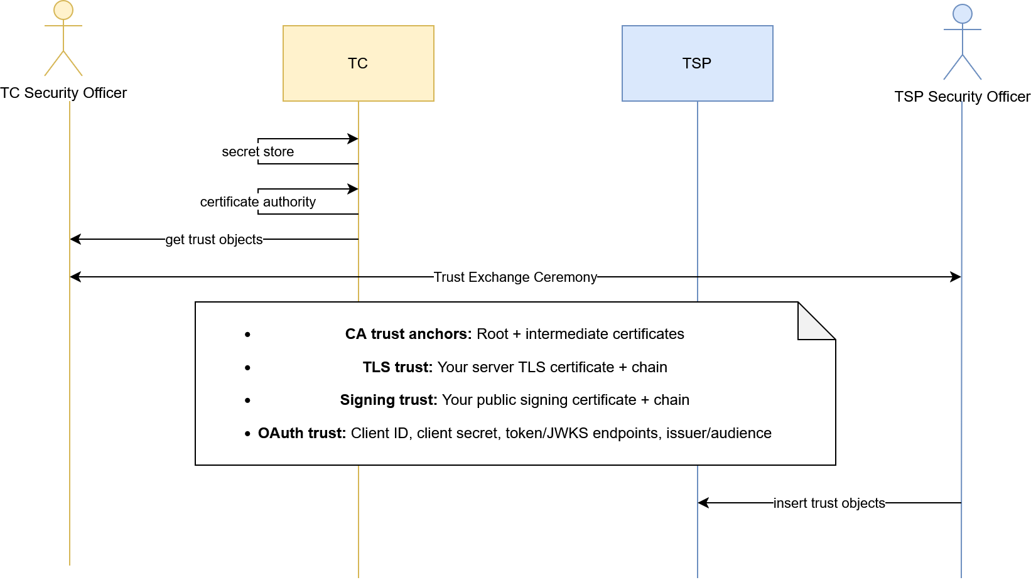
Figure 9 Trust Object Exchange

Privacy
- The EETS Provider shall ensure compliance with current Directive 95/46/EC (General Data Protection Regulation) and Directive 2002/58/EC concerning the processing of personal data and the protection of privacy and future regulations.
- The EETS Provider shall ensure that the data processed under this contract are hosted within the European Union or any other country having a compliance agreement with the EU.
- The EETS Provider supports the Toll Charger and other Authorities in the fulfillment of Data Protection Legislation.

General Requirements
The timings and other configurations mentioned are considered configurations and might change according to the needs of the system, for example due to performance considerations. It is expected that TSP solution can adapt to changes required. The system adheres to data minimization principle, meaning it is intended to not collect more data than needed. This requirement may be in contradiction with the ISO 16986 and ISO 12855 standards prescribing mandatory fields, not required by the system. This circumstance is especially prominent in the exchange of vehicle description data. As such the system may receive data from EETS TSP to comply to the standard but may discard them if not needed and in return provide only default values.
EETS TSPs are responsible for the correctness of the vehicle characteristics provided in the course of the data exchange.

Configurations and Definitions
This section manages the configuration and definitions applicable to the project.

Specific configurations
The following project specific restrictions and configurations apply.

APCI Object

Example Message APCI Structure
The following table gives an overview of the APCI object structure used, ordered alphabetically.
APCI |  | Description
aidIdentifier |  | Application Identifier specifying the ISO 12855 protocol version
apduDate |  | APDU creation timestamp in GeneralizedTime format
apduIdentifier |  | Unique APDU message identifier assigned by the originator for message tracking and acknowledgement correlation
apduOriginator |  | Entity that created the APDU content (toll charger or toll service provider)
 | .countryCode | country code of the apduOriginator
 | .providerIdentifier | provider identifier of the apduOriginator
informationRecipientId |  | Entity responsible for processing the APDU content (toll charger or toll service provider)
 | .countryCode | country code of the informationRecipient
 | .providerIdentifier | provider identifier of the informationRecipient
informationSenderId |  | Entity physically transmitting the APDU message (may differ from originator in intermediary scenarios)
 | .countryCode | country code of the information sender
 | .providerIdentifier | provider identifier of the information sender
inResponseToApduId |  | Optional reference to a previous APDU identifier. Used in Ack ADUs
 | .apduIdentifier | dentifier of the related APDU message being referenced. Used in Ack ADUs
 | .apduOriginator | Originator of the related APDU message being referenced. Used in Ack ADUs
 | .countryCode | country code of the apdu originator. Used in Ack ADUs
 | .providerIdentifier | provider identifier of the apdu originator. Used in Ack ADUs
Table 8 EETS APCI object

Toll Declaration

Configurations
Configuration option | Value | Owner
position storing interval | 1 position every 10 seconds | EETS TSP
position reporting frequency | every 30 minutes | EETS TSP
toll domain area | the country border of Lithuania extended by a 250 meter corridor | EETS TSP
Toll Declaration ADUs | contains list of positions based on position storing interval and position reporting frequency. | EETS TSP
 | Comment: Prescribed configuration is expected content. It is acknowledged that depending on driving situation, stand still, or end of a trip the number of positions inside a TD may be reduced or position storing intervals may be skipped.
maximum number of TD ADUs | 50 | EETS TSP
charging relevant vehicle attributes | - vehicleDescription  - specificCharacteristics  - descriptiveCharacteristics  - engineCharacteristics  - environmentalCharacteristics  - euroValue  - futureCharacteristics  - co2Class  - vehicleAxles  - vehicleAxlesNumber  - numberOfAxles  - tractorAxles  - vehicleClass  - weightLimits  - vehicleTrainMaximumWeight | EETS TSP
Table 9 EETS TD configurations

Example Message Structure
The following table gives an overview of the TD ADU message structure, ordered alphabetically.
TollDeclarationADU. |  |  |  |  |  |  |  | Description
[0].actionCode |  |  |  |  |  |  |  | used to specify the action of the sender. Value 0 (send) is allowed
[0].actionRequest |  |  |  |  |  |  |  | the required action to perform. Value 5 (process) is allowed.
[0].aduIdentifier |  |  |  |  |  |  |  | the unique identifier of the adu
[0].chargeReport |  |  |  |  |  |  |  | charge report object to inform charge data. only 1 item is allowed
 | [0].chargeReportCounter |  |  |  |  |  |  | incremental enumeration of the charge report per Obe
 | [0].obeId |  |  |  |  |  |  | obe identifier object
 |  | .equipmentObuId |  |  |  |  |  | unique equipmentId for a manufacturer and customer, according to ISO 15509, 1+4 Bytes, first byte length
 |  | .manufacturerId |  |  |  |  |  | identifier of the manufacturer of the device
 | [0].paymentMeans |  |  |  |  |  |  | the object to inform about the payment means
 |  | .paymentMeansExpiryDate |  |  |  |  |  | expiry date of the payment means
 |  |  | .day |  |  |  |  | expiry date of the payment means, day of expiry
 |  |  | .month |  |  |  |  | expiry date of the payment means, month of expiry
 |  |  | .year |  |  |  |  | expiry date of the payment means, year of expiry
 |  | .paymentMeansUsageControl |  |  |  |  |  | TSP specific usage control of the payment means
 |  | .personalAccountNumber |  |  |  |  |  | personal account number of the payment means.
 | [0].serviceProviderContract |  |  |  |  |  |  | TSP contract identifier of the user in questions
 |  | .contextVersion |  |  |  |  |  | TSP specific usage, not interpreted by the solution
 |  | .contractProvider |  |  |  |  |  | TSP identifier
 |  |  | .countryCode |  |  |  |  | country code of the TSP as accredited
 |  |  | .providerIdentifier |  |  |  |  | provider identifier of the TSP as accredited
 |  | .typeOfContract |  |  |  |  |  | TSP specific usage, not interpreted by the solution
 | [0].tollContextOperator |  |  |  |  |  |  | operator of the Toll Charger
 |  | .countryCode |  |  |  |  |  | country code of the toll charger, fixed to LT
 |  | .providerIdentifier |  |  |  |  |  | provider identifier of the toll charger, fixed to (To Be Defined)
 | [0].usageStatementList |  |  |  |  |  |  | list of usage statements
 |  | [0].listOfRawUsageData |  |  |  |  |  | list of raw usage data
 |  |  | .rawDataList |  |  |  |  | list of positions and meta information
 |  |  |  | [0].additionalGnssData |  |  |  | GNSS meta information required to accurately map match, includes information such as speed, course, etc.
 |  |  |  | [0].measuredPosition |  |  |  | details on the loaction measured by GNSS chip
 |  |  |  |  | .altitude |  |  | altitude of the measured location
 |  |  |  |  | .latitude |  |  | latitude of the measured location
 |  |  |  |  | .longitude |  |  | longitude of the measured location
 |  |  |  | [0].timeWhenMeasured |  |  |  | UTC time when the measured location was recorded
 |  |  | .vehicleDescription |  |  |  |  | information about the vheicle characteristics
 |  |  |  | .specificCharacteristics |  |  |  | object to inform specific characteristics
 |  |  |  |  | .descriptiveCharacteristics |  |  | descriptive characteristics used to inform about agricultural use or not
 |  |  |  |  | .engineCharacteristics |  |  | fuel / engine type used by the vehicle, e.g.: hydrogen, battery
 |  |  |  |  | .environmentalCharacteristics |  |  | object to inform environmental characteristics
 |  |  |  |  |  | .euroValue |  | euro value of the vehicle, "no entry" in case not available or not known
 |  |  |  |  | .futureCharacteristics |  |  | object to inform future characteristics
 |  |  |  |  |  | .co2Class |  | co2 emission class of the vehicle, "no entry" in case not available or not known
 |  |  |  | .vehicleAxles |  |  |  | object to inform vehicle axles
 |  |  |  |  | .vehicleAxlesNumber
 |  |  |  |  |  | .numberOfAxles
 |  |  |  |  |  |  | .tractorAxles | number of tractor axles, needs to be 2 or higher.
 |  |  |  | .vehicleClass |  |  |  | vehicle class indicating the UNECE vehicle category as defined in ISO 15509
 |  |  |  | .weightLimits |  |  |  | objec to inform weight limits
 |  |  |  |  | .vehicleTrainMaximumWeight |  |  | the maximum permissable weight of the whole vehicle train (including trailer)
 |  | [0].tollContextOperator |  |  |  |  |  | operator of the Toll Charger
 |  |  |  | .countryCode |  |  |  | country code of the toll charger, fixed to LT
 |  |  |  | .providerIdentifier |  |  |  | provider identifier of the toll charger, fixed to (To Be Defined)
 |  | [0].usageStatementId |  |  |  |  |  | unique identifier of the usagestatement within the CR
 | [0].vehicleLpNr |  |  |  |  |  |  | license plate number ojbect
 |  | .alphabetIndicator |  |  |  |  |  | alphabet indicator used to transmit the LPN. value utf8 is required
 |  | .countryCode |  |  |  |  |  | two letter country code identifying the country the vehicle is registered in.
 |  | .licencePlateNumber |  |  |  |  |  | plain text license plate number following restrictions apply:  latin characters are allowed A to Z and numbers 0 to 9, no special characters, blanks, hyphens, etc are allowed  minimum length 1  maximum length 10
[0].tollDeclarationId |  |  |  |  |  |  |  | Unique toll declaration identifier within the issuing toll service provider
 | .declarationId |  |  |  |  |  |  | Unique declaration number within the issuing toll service provider
 | .issuerId |  |  |  |  |  |  | Toll service provider identifier issuing this toll declaration
 |  | .countryCode |  |  |  |  |  | country code of the TSP as accredited
 |  | .providerIdentifier |  |  |  |  |  | provider identifier of the TSP as accredited
Table 10 EETS TD object

Billing Detail

Configurations
Configuration option | Value | Owner | Comment
billing detail aggregation period | every 24 h | TC
Table 11 EETS BD configurations

Example Message Structure
The following table gives an overview of the BD ADU message structure, ordered alphabetically.
BillingDetailsADU. |  |  |  |  |  |  |  |  | Description
[0].actionCode |  |  |  |  |  |  |  |  | It is used to specify the intended action associated with the billingdetail. Only send is allowed
[0].aduIdentifier |  |  |  |  |  |  |  |  | the identifier of the billing detail
[0].billingDetailsAmount |  |  |  |  |  |  |  |  | information on the billing details amount
 | .paymentFeeAmount |  |  |  |  |  |  |  | the total amount of the biling detail
 | .paymentFeeUnit |  |  |  |  |  |  |  | the unit of the billing details amount in currency and unit e.g.; EUR in Cents
[0].period |  |  |  |  |  |  |  |  | information on the period covered by the Billing Detail.
[0].period.beginOfPeriod |  |  |  |  |  |  |  |  | the begin of the period covered by the BD
[0].period.endOfPeriod |  |  |  |  |  |  |  |  | the end of the period covered by the BD
[0].tollContextOperator |  |  |  |  |  |  |  |  | the toll charger identifier
 | .countryCode |  |  |  |  |  |  |  | the country code of the toll charger
 | .providerIdentifier |  |  |  |  |  |  |  | the provider identifier of the toll charger
[0].usage |  |  |  |  |  |  |  |  | information on the usage
 | .tollContextName |  |  |  |  |  |  |  | the name of the toll context, string configuration
 | .usageList |  |  |  |  |  |  |  | entry of a usage statement
 |  | [0].usageListEntry |  |  |  |  |  |  | information on a usage list entry, contains either forSectionedRoads element or freeTextDetail element
 |  |  | .forSectionedRoads |  |  |  |  |  | information on usage for a sectioned road
 |  |  |  | .appliedLocalVehicleClass |  |  |  |  | information on the local vehicle class used
 |  |  |  |  | .appliedLocalVehicleClassId |  |  |  | the local vehicle class of the vehicle subject to charge
 |  |  |  | .appliedTariffTableVersion |  |  |  |  | information on the tariff table version used
 |  |  |  | .appliedTimeClass |  |  |  |  | information of the time class used
 |  |  |  |  | .appliedTimeClassId |  |  |  | the time class identifier applied during rating
 |  |  |  | .appliedUserClass |  |  |  |  | information of the user class identified
 |  |  |  |  | .appliedUserClassId |  |  |  | fixed value to 0 until more business logic is available
 |  |  |  | .howManyTimes |  |  |  |  | how often each section was used fixed value set to 1
 |  |  |  | .usageDistance |  |  |  |  | information on the distance driven/applied
 |  |  |  |  | .distanceUnit |  |  |  | the unit of the distance covered, e.g.: kilometers
 |  |  |  |  | .distanceValue |  |  |  | the total distance covered by the charge object
 |  |  |  | .usageExternalCosts |  |  |  |  | the external cost entry
 |  |  |  |  | [0].externalCostType |  |  |  | the type of the external costs, currently supported is Co2 (4).
 |  |  |  |  | [0].externalCostValue |  |  |  | information on the external cost fee
 |  |  |  |  |  | .paymentFeeAmount |  |  | the fee of the external costs, a share of the overall costs
 |  |  |  |  |  | .paymentFeeUnit |  |  | the unit of the external cost fee e.g.: EUR in Cents
 |  |  |  | .usedSections
 |  |  |  |  | [0].appliedLocationClass |  |  |  | information on the location class used
 |  |  |  |  |  | .appliedLocationClassId |  |  | the location class of the road belonging to the detected charge object
 |  |  |  |  | [0].usedChargeObjectId
 |  |  |  |  |  | .chargeObjectDesignation |  |  | the identifier of the detected charge object
 |  |  |  | .vehicleDescription |  |  |  |  | information about the vheicle characteristics
 |  |  |  |  | .specificCharacteristics |  |  |  | object to inform specific characteristics
 |  |  |  |  |  | .descriptiveCharacteristics |  |  | descriptive characteristics used to inform about agricultural use or not
 |  |  |  |  |  | .engineCharacteristics |  |  | fuel / engine type used by the vehicle, e.g.: hydrogen, battery
 |  |  |  |  |  | .environmentalCharacteristics |  |  | object to inform environmental characteristics
 |  |  |  |  |  |  | .euroValue |  | euro value of the vehicle, "no entry" in case not available or not known
 |  |  |  |  |  | .futureCharacteristics |  |  | object to inform future characteristics
 |  |  |  |  |  |  | .co2Class |  | co2 emission class of the vehicle, "no entry" in case not available or not known
 |  |  |  |  | .vehicleAxles |  |  |  | object to inform vehicle axles
 |  |  |  |  |  | .vehicleAxlesNumber
 |  |  |  |  |  |  | .numberOfAxles
 |  |  |  |  |  |  |  | .tractorAxles | number of tractor axles, needs to be 2 or higher.
 |  |  |  |  | .vehicleClass |  |  |  | vehicle class indicating the UNECE vehicle category as defined in ISO 15509
 |  |  |  |  | .weightLimits |  |  |  | objec to inform weight limits
 |  |  |  |  |  | .vehicleTrainMaximumWeight |  |  | the maximum permissable weight of the whole vehicle train (including trailer)
 |  |  | .freeTextDetail |  |  |  |  |  | object only used according to bilateral agreement for needed adjustments
 |  |  |  | .textDetail
 |  |  |  |  | .textLanguage |  |  |  | language of the text, default 1 - english
 |  |  |  |  | .text |  |  |  | free text detail as set by the agent e.g.: refBDId, as per agreed on 1.1.2027
 |  |  |  | .usageExternalCosts
 |  |  |  |  | .[0]externalCostType |  |  |  | the type of the external costs, currently supported is Co2 (4).
 |  |  |  |  | .[0]externalCostValue |  |  |  | information on the external cost fee
 |  |  |  |  |  | .paymentFeeAmount |  |  | the fee of the external costs, a share of the overall costs
 |  |  |  |  |  | .paymentFeeUnit |  |  | the unit of the external cost fee e.g.: EUR in Cents
[0].userId |  |  |  |  |  |  |  |  | information on the user
 | .licencePlateNumber |  |  |  |  |  |  |  | information on the licenseplate number
 |  | .alphabetIndicator |  |  |  |  |  |  | the alphabet indicator, should always be UTF-8
 |  | .countryCode |  |  |  |  |  |  | country code of the license plate
 |  | .licencePlateNumber |  |  |  |  |  |  | plain text license plate number following restrictions apply:  latin characters are allowed A to Z and numbers 0 to 9, no special characters, blanks, hyphens, etc are allowed  minimum length 1  maximum length 10
 | .obeId |  |  |  |  |  |  |  | Identifier of the device
 |  | .equipmentObuId |  |  |  |  |  |  | unique equipmentId for a manufacturer and customer, according to ISO 15509, 1+4 Bytes, first byte length
 |  | .manufacturerId |  |  |  |  |  |  | identifier of the manufacturer of the device
Table 12 EETS BD object

Payment Claim Configurations
Configuration option | Value | Owner | Comment
payment claim aggregation period | every 14 days | TC
maximum number of billing details | 5000 | TC
Table 13 EETS PC configurations

Example Message Structure
The following table gives an overview of the PC ADU message structure, ordered alphabetically.
PaymentClaimADU. |  | Description
[0].actionCode |  | It is used to specify the intended action associated with the payment claim. Only send is allowed
[0].aduIdentifier |  | identifier of the payment claim
[0].endDateTime |  | the end of the period the payment claim belongs to
[0].paymentClaimAmount |  | information on the amount of the payment claim
 | .paymentFeeAmount | the amount of the payment claim without VAT
 | .paymentFeeUnit | the currency and unit e.g.: EUR in Cents
[0].paymentClaimStatus |  | the status of the payment claim, first version if created, amended version if resent after a change
[0].paymentClaimDetails |  | object only used in case of adjustment
. paymentDetailText |  | free text as bilaterally agreed, should contain original PC ID as a reference
[0].referenceDetailsList |  | array of ADUs referenced
 | [0].referencedAduIdentifier | in case of a billing detail the reference of the billing detail adu
 | [0].referencedAduType | the type of ADU that is referenced only AduType (billingDetailsAdu | paymentClaimAdu) are allowed
[0].startDateTime |  | the begin of the payment claim aggregation period
[0].typeOfContent |  | the type of content of the payment claim, will be 0 – toll or 2 - tollCredit
Table 14 EETS PC object

Exception List Configurations
Configuration option | Value | Owner | Comment
full exception list exchange window | daily between 01:00 and 04:00 | EETS TSP | Mutally agreed between both parties.
Table 15 EETS EL configurations

Example Message Structure
The following table gives an overview of the EL ADU message structure, ordered alphabetically.
ExceptionListADU. |  |  |  | Description
[0].actionCode |  |  |  | used to specify the action of the sender. Value 0 (send) is allowed
[0].actionRequest |  |  |  | the required action to perform. Value 5 (process) is allowed.
[0].aduIdentifier |  |  |  | the unique identifier of the adu
[0].exceptionListEntries |  |  |  | object to inform the entries of the exception list
 | [0].actionRequested |  |  | Requested action for this exception entry (3 = accept, 4 = removeObe)
 | [0].reasonCode |  |  | List of reason codes explaining why the user is on this exception list  - 0 = notToBeDisclosed,  - 8 = userOnAccessList,  - 34 = accessListChangedLicencePlate,  - 35 = accessListChangedObu
 | [0].userId |  |  | information on the user
 |  | .licencePlateNumber |  | information on the licenseplate number
 |  |  | .alphabetIndicator | the alphabet indicator, should always be UTF-8
 |  |  | .countryCode | country code of the license plate
 |  |  | .licencePlateNumber | plain text license plate number following restrictions apply:  latin characters are allowed A to Z and numbers 0 to 9, no special characters, blanks, hyphens, etc are allowed  minimum length 1  maximum length 10
 |  | .obeId |  | Identifier of the device
 |  |  | .equipmentObuId | unique equipmentId for a manufacturer and customer, according to ISO 15509, 1+4 Bytes, first byte length
 |  |  | .manufacturerId | identifier of the manufacturer of the device
 |  | .pan |  | personal account number of the payment means.
[0].exceptionListType |  |  |  | Exception list category blockListFull (1), accessListFull (2)
[0].exceptionListVersion |  |  |  | Sequential version number incremented with each exception list update
[0].exceptionValidityStart |  |  |  | Date and time when this exception list becomes valid (GeneralizedTime format per ASN.1)
Table 16 EETS EL object

Acknowledgement Configurations
no specific configurations for acknowledgements exist

Example Message ACK ADU Structure
The following table gives an overview of the ACK ADU object structure, ordered alphabetically.
AcknowledgementADU. |  | Description
[0].actionCode |  | used to specify the action of the sender. Value 0 (send) is allowed
[0].actionRequest |  | the required action to perform. Value 5 (process) is allowed.
[0].apduAckCode |  | APDU-level acknowledgement status code (1 = accepted, 2 = rejected - syntax error, 3 = rejected - semantic error)
[0].apduIdentifier |  | APDU message identifier being acknowledged
[0].issues |  | Details on issues, only used in case of apduAckCode = 1.
 | [0].issueAduIdentifier | ADU identifier of the ADU containing this issue
 | [0].issueLocation | XPath expression or field path identifying the location of the issue within the ADU
 | [0].issueContent | Detailed description of the issue found.
 | [0].issueCode | Issue severity code (0-3999 = errors causing rejection, 4000 = warning, 4001-65535 = other codes per ISO 12855 and bilateral agreements)
Table 17 EETS ACK object

- END OF DOCUMENT -

