LTU National GNSS Road Toll System
Guide to the Integration of OBE into the System
Document No. 30010
Version 1.0

Author | Paul Litzinger
Reviewed by: | Roman Trinko
Approved by: | Hans Gidoff

Overview of changes.
No. | Version | Status | Date | Submitted by | Change type
1 | 0.1 | Draft | 17 April 2026 | Paul Litzinger | First version
2 | 1.0 | Published | 23 June 2026 | Paul Litzinger | Released version
Table 1. Overview of changes

Link to status, versions and data classification.
Status:
Draft | The document being processed
Released | The document has been checked and published; it can only be amended by updating the version number.
Out of date | The document is no longer valid
Versions:
0.1, 0.2 | Draft versions
1.0 | The first released version with the status “Released”
1.1, 1.2, etc. | Draft versions that supplement version 1.0
2.0 | The second released version, with the status “Released”
Data classification
Public | No restrictions
For internal use only | Access restricted to Kapsch internal and external staff only
Confidential | Access restricted to selected active “Active Directory” and/or “SharePoint” groups (by default)
Secret | Access restricted to selected staff only; server encryption required

Page
Table of content
1 Purpose 5
2 Data exchange 6
2.1 Message exchange 6
2.1.1 General aspects of messages 7
2.2 Toll declaration 8
2.2.1 Business context 8
2.2.2 Communication process 9
2.2.3 Additional requirements 10
2.3 Acknowledgments 10
2.3.1 Business context 11
2.3.2 Communication process 11
2.3.3 Additional requirements 11
3 General requirements, obligations and considerations 12
3.1 Security aspects 12
3.1.1 Exchange of trust objects 15
3.2 Privacy 15
3.3 General requirements 16
4 Configurations and definitions 17
4.1 Specific configurations 17
4.1.1 APCI object 17
4.1.1.1 Example of an APCI message structure 17
4.1.2 Toll declaration 19
4.1.2.1 Configuration 19
4.1.2.2 Example of message structure 20
4.1.3 Acknowledgement configurations 23
4.1.3.1 Example of the ACK ADU structure 23

List of figures
Fig. 1. High-level message exchange in EETS 7
Fig. 2. Toll declaration exchange 9
Fig. 3. Security communication flow 14
Fig. 4. Exchange of trust objects 15

List of tables
Table 1. Overview of changes 2
Table 2. Data exchanged 6
Table 3. Deadlines for declaring tolls 10
Table 4. Multi-layered security architecture 12
Table 5. EETS APCI object 18
Table 6. EETS TD configurations 19
Table 7. EETS TD object 22
Table 8. EETS ACK object 23

Purpose

This document describes the integration requirements and aspects to be taken into account by OBE Providers, as well as the data objects exchanged between the Toll Charger and the OBE Provider, based on the EFC (Electronic Fee Collection) toolset standard ISO 12855. OBE Providers integrate with the solution in accordance with the standard “Electronic fee collection – Information exchange between service provision and toll charging” (ISO 12855:2025) and the related standard “Electronic fee collection – System architecture for vehicle-related tolling. Part 3: Data dictionary” ISO/TS 17573-3:2021. The main ASN.1 specifications can be found in ISO 12855 ASN.1 and ISO 17575 ASN.1. As no relevant version of the ISO 16986 profile had been published at the time of drafting this document, the solution has been aligned with the available draft version. The right to make amendments is reserved.
This document provides a general description of the solution and its configurations. Specific project configurations take precedence over general aspects and shall be defined during the integration process.

Data exchange
The following two entities exchange the data objects described in this section:
- The Toll Charger (TC) and
- The OBE Provider (OBE-P)

The following incoming message flows are used in this solution: OBE-P sends a request to TC

In accordance with the ISO standard, data is exchanged using information exchange messages containing APCI and ADU information.

Message exchange
Messages are exchanged using an HTTP web service, which exposes an endpoint to which sendAPDU messages are sent using the POST method. In accordance with the ISO 12855 standard, the main object for message exchange is the “infoExchange” object. This object, also known as an application protocol data unit, consists of:
- one instance of the Application Protocol Control Information (APCI) object, including information about the sender, the recipient, the identifier, etc.
- one or more Application Data Unit (ADU) objects of the same type.
These ADUs are automatically exchanged via the EETS interface. Further details on data objects, formats and constraints on value ranges can be found in the interface specification.
Application Data Object | Direction | Initiator | Exchange mechanism
Toll Declarations ADU | Incoming | OBE Provider | HTTP WebService
Acknowledgement ADUs | Outgoing | TC | HTTP WebService
Table 2. Data exchanged
In order to establish a trust-based connection between the TC and the OBE Provider’s solution, it is necessary to exchange the trust object ADU. This exchange is carried out manually. Other required data objects or information exchanged manually are userDetails and EFC context data.
The diagram below illustrates the high-level message exchange process, including the sending of a message and an asynchronous acknowledgement response. The flow diagram illustrates an example where a TC receives a message and responds with an acknowledgement ADU; a typical example is the Toll Declaration ADU.

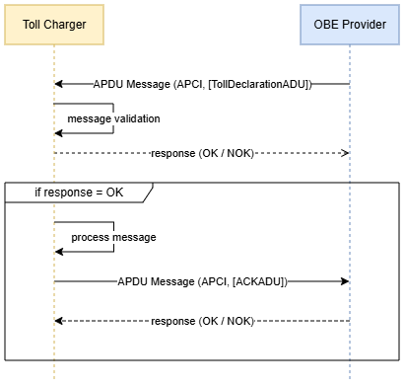
Fig. 1. High-level message exchange in the EETS

As illustrated, only those messages that successfully pass the message validation process will be processed further in the decision. Therefore, successful data transmission alone is not sufficient for the sender to conclude that the data sets are correct in accordance with all business rules and that the recipient has accepted them. The asynchronous technical acceptance process may detect a breach of business rules and result in the data being rejected. Depending on the outcome of the process, an asynchronous acknowledgement (ACK) ADU notifies the recipient of acceptance or rejection of the message. The ADU message transmitted during this process provides specific information if technical errors or warnings occurred during data processing.

General aspects of messages
- The JSON Encoding Rules (JER) are used in the decision
- All specified times are given in a generalised format and in UTC ± 0. The required format is “YYYYYMMDDHHHmmssZ”.
- In the event of a transmission error (e.g. if the OBE Provider’s system is unavailable), the systems attempt to resend the message. If the message cannot be delivered for an extended period, the recipient is notified and further action is agreed upon by mutual consent.
The following sections describe the different types of data elements in the application in detail.

Toll declaration
This section describes the process for exchanging toll declarations and the associated requirements.

Business context
A GNSS device is used to record location information during the collection process. A GNSS device is a standalone device capable of recording GNSS location information and transmitting it to the central road toll system. The GNSS device is fitted to a vehicle subject to road tolls in order to record the vehicle’s movement. The GNSS device records the vehicle’s location (i.e. GNSS positions) at a set and configurable frequency – the position sampling interval (e.g. every 5 seconds) – whilst it is within the relevant toll zone. For each position, the GNSS device records the following information to meet the requirements of the solutions:
- longitude,
- latitude,
- altitude (optional),
- date and time, and
- the following quality parameters:
- speed
- heading
- horizontal accuracy
Optionally, a parking filter may be installed in the devices to prevent the accumulation of position “clouds” during traffic congestion or whilst the vehicle is waiting at a red traffic light. The collected location data is supplemented with vehicle characteristics relevant to tolling and aggregated according to a defined and configurable aggregation period – the frequency of position reporting (e.g. every 5 minutes). Vehicle attributes related to charging constitute a toll-domain-specific set and may vary across different toll domains depending on the tariff table used. The solution, inter alia, supports the following typical attributes:
- Vehicle class: as per the vehicle’s registration documents
- Vehicle axles: tractor and trailer axles as per the vehicle registration documents and the current configuration of the vehicle combination
- Vehicle weight restrictions: as per the vehicle’s registration documents
- Euro class: as per the vehicle registration document
- CO₂ emissions class: as per the EU CO₂ emissions classification scheme, based on the vehicle registration documents
In order to identify the vehicle and the device used during data collection, the following identifiers are assigned to the packaged location data:
- Licence plate number: country code and licence plate number as per the vehicle registration documents
- Device identifier: a unique identifier for the GNSS device used to record location information, consisting of the Provider, manufacturer and equipment identifiers
The received position data packet is transmitted to the central road toll system to determine whether toll roads are being used and to calculate the relevant toll charges.

Communication process
The tolling process begins with the collection of position packets by the OBE, as described earlier in this document. These position packets are received from the OBE by its contracted OBE Provider. The OBE Provider generates toll declaration ADUs and transmits them to the TC. The solution receives toll declaration ADUs (TD ADUs) from the accredited OBE Provider, packaged into information exchange messages at the agreed aggregation level (maximum number of TD ADUs). Upon successful syntactic and semantic validation of the TD ADUs, the solution responds with an asynchronous acknowledgement ADU (ACK ADU), confirming receipt and successful processing of all submitted TD ADUs. If errors occur during validation, the solution rejects individual TD ADUs, specifying the relevant error code. The performed validations include, inter alia, the following:
- Syntactic correctness (Error code: apduNotOk)
- Syntax correctness of the TD ADU (Error code: apduNotOk)
- Duplicate transmission of a TS ADU (Error code: tollDeclarationDuplicateTollDeclarationRejected)
Internal errors may occur due to oversized messages (e.g. the TD ADU list in the request was outside the agreed value range). “Only successfully validated TD ADUs shall be used for toll calculation. Exchanges are carried out in accordance with the communication and timing parameters defined in the ISO 16986 standard:

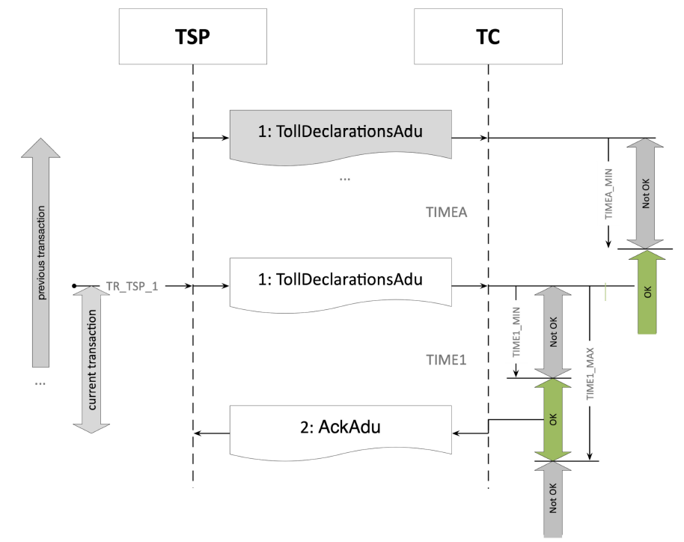
Fig. 2. Toll declaration exchange

With the following configurable times:
Activation and/or time | Value | Default value
TR_TSP_1 | OBE-P may initiate the TOLLDECLARATION_SECT operation at any time after TIMEA_MIN. | Default value = 30 minutes, in accordance with the agreed reporting interval under the OBE
TIMEA_MIN | The minimum time between the transmission of two TollDeclarationADUs by two consecutive TOLLDECLARATION_SECT operations. | Default value = 0 seconds, to enable the creation of a TD ADU list
TIME1_MIN | The minimum time within which the TC must acknowledge receipt of a toll declaration by sending an ACK ADU. | Default value = 0 seconds, to allow immediate rejection in the event of a syntax error
TIME1_MAX | Maximum time within which the TC must acknowledge receipt of a toll declaration by sending an ACK ADU. | Default value = 24 h. Take into account operational procedures in the event of maintenance or unplanned downtime. Under normal conditions, a response should be received within a few (10) seconds.
Table 3. Toll declaration deadlines

Additional requirements
- Toll declaration ADUs shall be transmitted in such a way that the sequence of items is chronologically ascending.
- Every TD ADU that has been transmitted and positively acknowledged is subject to a charge.
- An APDU containing a TD ADU that has been wholly or partially rejected by an ACK ADU must not be resubmitted. The OBE Provider is expected to create a new APDU with corrected TD ADUs so that they can be processed.
- Processing of toll declaration data containing future GNSS timestamps is not supported. In the solution, such TDs shall be accepted, but shall be silently rejected during the map alignment process.
- The solution adheres to the principle of data minimisation. Vehicle characteristics are provided to the solution as input data. Only vehicle characteristics relevant to tolling are required for the solution to process the toll. However, the structure of the standard ISO 12855 does not require the transmission of any vehicle characteristics related to tolling. For example: for the data object “Axles”, the axle height, tyre type, and the axles of the tractor and trailer must be transmitted. Not all the information included in the object “Axles” object is necessary for tolling purposes; for example, only the tractor and trailer axles may be taken into account. The solution should receive all mandatory fields but ignore values that are not relevant for tolling.

Acknowledgments
This section describes the acknowledgment exchange process and the associated requirements.

Business context
The solution exchanges in Acknowledgement (ACK) ADU to complete the business process. The ACK ADU provides business information regarding the acceptance or rejection of the specified ADU. An ACK ADU may be used to report the acceptance or rejection of the entire APDU, or to report only the rejection of individual ADUs, specifying additional reasons. In general, the following logic applies:
Field | Value and usage
apduAckCode | - If apduAckCode is apduOK and the issue structure is omitted or left empty, all ADUs are accepted.  - If apduAckCode is apduOK but a question structure is present and contains questions, then the questions listed with issueCode are rejected.  - If apduAckCode is not apduOK, the entire message, including all its ADUs, is rejected.
Issues | This object specifies the specific ADU identifiers in the event of a partial rejection.
issueCode | Must be set to one of the values supported in the relevant business context

Communication process
The TC initiates the transmission of the ACK ADU. Once the ACK ADU has been generated, it is immediately sent to the OBE Provider. The ISO 16986 profile does not specify any time or activation constraints.

Additional requirements
There are no additional requirements

General requirements, obligations and considerations
This section describes the general requirements and obligations that OBE Providers must fulfil, as well as the aspects they need to take into account.

Security aspects
The table below provides an overview of the multi-layered security architecture:
Layer | What it protects | When it provides protection | Why it is important
TLS | Confidentiality and integrity of transmission | For every request | Protection against eavesdropping and tampering during transmission
OAuth 2.0 + ClientID + Client secret | Client authentication | When making a token request | Ensures that only trusted clients can obtain a JWT
JWT access token | Authorisation and identification | During every API call | Ensures permissions are enforced and authenticates the caller’s identity
Refresh token | Session continuity | When the access token expires | Enables long sessions without revealing the API key
Signing of payloads | Message integrity | In every signed request | Ensures that the payload cannot be altered without detection
Table 4. Multi-layered security architecture
When a client interacts with the system, security is ensured through several layers. Each mechanism protects a different part of the communication flow. TLS ensures encrypted transmission, so data cannot be intercepted or modified during transmission. The authentication stage takes place when the client submits its client ID and secret key to the OAuth 2.0 token endpoint, thereby proving that it is an authorised application, and in return receives a short-lived JWT. The JWT then serves as the client’s access token for carrying out business operations. The JWT is validated with every request to ensure the caller’s authentication and authorisation. The JWT have a short validity period to minimise the risk of compromise, whilst refresh tokens allow the client to obtain new access tokens repeatedly without having to resubmit the API key. Finally, payload signing ensures message-level integrity: the client signs the request’s content with its private key, and the system verifies the signature using the corresponding public key, thus, ensuring that the payload itself has not been altered. Together, these layers form a “defence-in-depth” model, which ensures transmission security, client authentication, authorisation of each request, secure maintenance of long-term sessions, and guarantees that the payload remains unaltered.
- TLS Secures the transmission channel by encrypting the data being transmitted and ensuring that the client is communicating with a legitimate server. It protects against eavesdropping and forgery during transmission, but does not verify the client’s authenticity or grant API access permission.
- OAuth 2.0 + clientID and secret key Secures the token issuance phase. The API key identifies the client application and allows it to obtain a JWT. This ensures that only registered and trusted clients can request for tokens.
- JWT access token Secures every API request. The JWT carries identity and authorisation claims, and is verified by your API gateway or backend system with every call. This ensures that the caller’s authenticity is verified and that they are authorised to perform the requested action.
- Refresh token Ensures session continuity. This allows the client to obtain new access tokens repeatedly without having to disclose the API key. This reduces risk whilst ensuring long-lasting sessions.
- Payload signing Ensures the integrity of the message. The client signs the payload with their private key, and the server verifies the signature using the client’s public key. This ensures that the payload remains unaltered, even if the data transmission layer is secure.
The diagram below provides an overview of the security architecture.

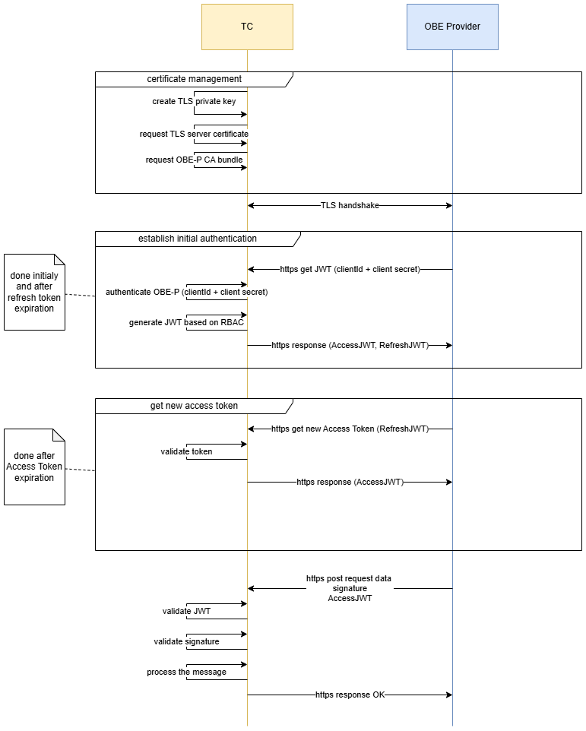
Fig. 3. Security communication flow

The chosen security architecture reflects the most modern IT system architecture. If new threats are detected or security schemes need to be updated due to other requirements, clients must support the updated scheme.

Exchange of trust objects
The system establishes initial trust by issuing OBE Provider and TC signing and communication certificates, as well as client authorisations. Trust objects are exchanged manually, with these exchanges being carried out by the security officers of the TC and the OBE Provider.

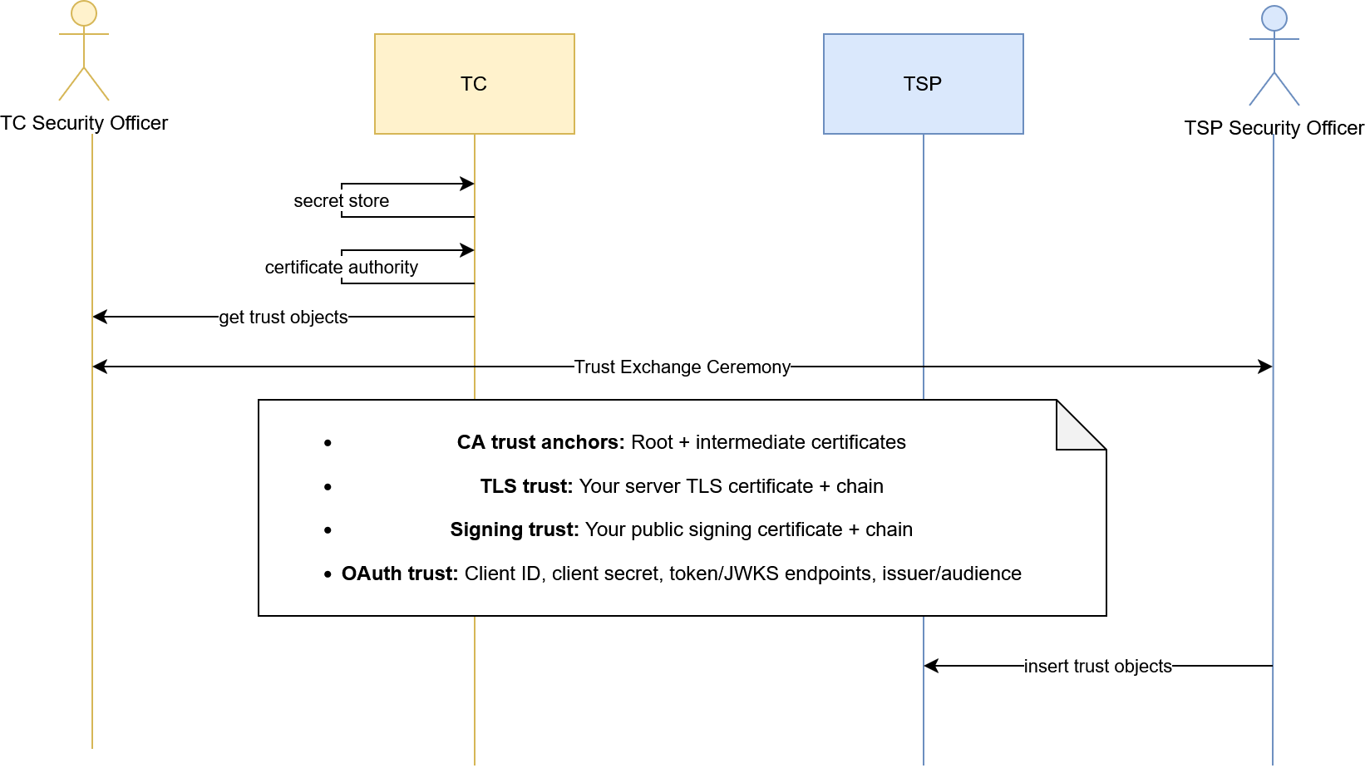
Fig. 4. Exchange of trust objects

Privacy
- The OBE Provider shall ensure compliance with the applicable provisions of Directive 95/46/EC (General Data Protection Regulation) and Directive 2002/58/EC on the processing of personal data and the protection of privacy, as well as any future regulations.
- The OBE Provider ensures that data processed under this contract is stored within the European Union or in any other country that has concluded an adequacy agreement with the EU.
- The OBE Provider assists the Toll Charger and other authorities in complying with data protection legislation.

General requirements
The durations and other configurations mentioned are considered to be configurations and may be modified in line with the requirements for the system, for example, for performance reasons. It is expected that the OBE Provider’s solution will be able to adapt to the necessary changes. The system adheres to the principle of data minimisation, i.e. it aims not to collect more data than is necessary. The afore-mentioned requirement may be in conflict with the standards ISO 16986 and ISO 12855, which specify mandatory fields that the system does not require. This is particularly important when vehicle description data changes. The system may receive data from the OBE Provider to comply with the standard, but may discard it if it is not required and provide only the default values.
The OBE Provider is responsible for the accuracy of the vehicle characteristics provided during data exchange.

Configurations and definitions
This section deals with the configuration and definitions applicable to the project.

Specific configurations
The following restrictions and configurations specific to this project apply.

APCI object

Example of an APCI message structure
The table below provides an alphabetical overview of the APCI object structures used.

APCI |  | Description
aidIdentifier |  | Programme identifier specifying the version of the ISO 12855 protocol
apduDate |  | APDU creation timestamp in GeneralizedTime format
apduIdentifier |  | A unique APDU message identifier assigned by the initiator, intended for message tracking and acknowledgemnt correlation
apduOriginator |  | The entity that generated the APDU content (the Toll Charger or the toll service provider)
 | .countryCode | apduOriginator country code
 | .providerIdentifier | The apduOriginator Provider identifier
informationRecipientId |  | Entity responsible for processing the content of the APDU (the Toll Charger or the toll service provider)
 | .countryCode | Country code of the information recipient
 | .providerIdentifier | Identifier of the information recipient’s service provider
informationSenderId |  | The entity physically transmitting the APDU message (may differ from the initiator in intermediary scenarios)
 | .countryCode | country code of the information sender
 | .providerIdentifier | The identifier of the information sender’s service provider
inResponseToApduId |  | Optional reference to the previous APDU identifier. Used in Ack ADU
 | .apduIdentifier | Identifier of the associated APDU message being referenced. Used in the Ack ADU
 | .apduOriginator | The originator of the associated APDU message being referenced. Used in the Ack ADU
 | .countryCode | The country code of the APDU originator. Used in the Ack ADU
 | . ProviderIdentifier | The identifier of the service provider of the APDU originator. Used in the Ack ADU
Table 5. EETS APCI object

Toll declaration

Configuration
Configuration option | Value | Owner
Position storage interval | 1 position every 10 seconds | OBE Provider
Frequency of position reporting | every 30 minutes | OBE Provider
Toll domain | The state border of the Republic of Lithuania, extended by a 250-metre-long corridor | OBE Provider
ADU Toll Declaration | A list of positions organised according to the retention period and reporting frequency of the positions. | OBE Provider
 | Note: The default configuration is indicative. It is recognised that, depending on the driving situation, the number of positions within the TD may be reduced or position storage intervals may be skipped when the vehicle is stationary or at the end of a journey.
Maximum number of TD ADUs | 50 | OBE Provider
Vehicle characteristics relevant to tolling | - vehicleDescription  - specificCharacteristics  - descriptiveCharacteristics  - engineCharacteristics  - environmentalCharacteristics  - euroValue  - futureCharacteristics  - co2Class  - vehicleAxles  - vehicleAxlesNumber  - numberOfAxles  - tractorAxles  - vehicleClass  - weightLimits  - vehicleTrainMaximumWeight | OBE Provider
Table 6:. EETS TD configurations

Example of message structure
The table below provides an alphabetical overview of the structure of a TD ADU message.
TollDeclarationADU. |  |  |  |  |  |  |  | Description
[0].actionCode |  |  |  |  |  |  |  | Used to specify the sender’s action. Permitted value: 0 (send)
[0].actionRequest |  |  |  |  |  |  |  | The required action to be performed. Permitted value: 5 (process).
[0].aduIdentifier |  |  |  |  |  |  |  | Unique ADU identifier
[0].chargeReport |  |  |  |  |  |  |  | A charge report object designed to provide information on charge data. Only 1 element is permitted
 | [0].chargeReportCounter |  |  |  |  |  |  | Sequential numbering of charge reports in accordance with the OBE
 | [0]. OBEId |  |  |  |  |  |  | OBE identifier object
 |  | .equipmentObuld |  |  |  |  |  | Unique manufacturer and customer equipment ID in accordance with ISO 15509, 1+4 bytes, length of the first byte
 |  | .manufacturerId |  |  |  |  |  | Equipment manufacturer identifier
 | [0].paymentMeans |  |  |  |  |  |  | Object providing information on payment methods
 |  | .paymentMeansExpiryDate |  |  |  |  |  | Expiry date of the payment method
 |  |  | .day |  |  |  |  | Expiry date of the payment instrument, day of expiry
 |  |  | .month |  |  |  |  | Expiry date of the payment instrument, month of expiry
 |  |  | .year |  |  |  |  | Expiry date of the payment instrument, year of expiry
 |  | .paymentMeansUsageControl |  |  |  |  |  | Special control of the use of payment instruments by the OBE Provider
 |  | .personalAccountNumber |  |  |  |  |  | personal account number of the payment instrument.
 | [0].service ProviderContract |  |  |  |  |  |  | Contract identifier of the relevant user’s OBE Provider
 |  | .contextVersion |  |  |  |  |  | Specific use by the OBE Provider, not interpreted in the decision
 |  | .contract Provider |  |  |  |  |  | OBE Provider identifier
 |  |  | .countryCode |  |  |  |  | Country code of the accredited OBE Provider
 |  |  | . ProviderIdentifier |  |  |  |  | Identifier of the accredited OBE Provider
 |  | .typeOfContract |  |  |  |  |  | Specific use by the OBE Provider, not interpreted in the decision
 | [0].tollContextOperator |  |  |  |  |  |  | Toll Charger’s operator
 |  | .countryCode |  |  |  |  |  | Toll Charger’s country code, set to LT
 |  | . ProviderIdentifier |  |  |  |  |  | Toll Charger’s service provider identifier, set in accordance with (to be defined)
 | [0].usageStatementList |  |  |  |  |  |  | List of usage statements
 |  | [0].listOfRawUsageData |  |  |  |  |  | List of raw usage data
 |  |  | .rawDataList |  |  |  |  | List of positions and metadata
 |  |  |  | [0].additionalGnssData |  |  |  | GNSS metadata required for precise map alignment, including information such as speed, heading, etc.
 |  |  |  | [0].measuredPosition |  |  |  | Detailed information about the position measured by the GNSS chip
 |  |  |  |  | .altitude |  |  | Altitude of the measured position
 |  |  |  |  | .latitude |  |  | Latitude of the measured position
 |  |  |  |  | .longitude |  |  | Longitude of the measured location
 |  |  |  | [0].timeWhenMeasured |  |  |  | UTC time when the measured location was recorded
 |  |  | .vehicleDescription |  |  |  |  | Information on the vehicle’s characteristics
 |  |  |  | .specificCharacteristics |  |  |  | Object providing information on specific characteristics
 |  |  |  |  | .descriptiveCharacteristics |  |  | Descriptive characteristics used to indicate whether or not the vehicle is used in agriculture
 |  |  |  |  | .engineCharacteristics |  |  | Type of fuel and/or engine used in the vehicle, e.g. hydrogen, battery
 |  |  |  |  | .environmentalCharacteristics |  |  | Object providing information on environmental characteristics
 |  |  |  |  |  | .euroValue |  | Value of the vehicle in EUR; if not available or unknown, “no data”
 |  |  |  |  | .futureCharacteristics |  |  | Object intended to provide information on future characteristics
 |  |  |  |  |  | .co2Class |  | The vehicle’s CO₂ emission class; if no data is available or is unknown, “no data”
 |  |  |  | .vehicleAxles |  |  |  | object intended to provide information on the vehicle’s axles
 |  |  |  |  | .vehicleAxlesNumber
 |  |  |  |  |  | .numberOfAxles
 |  |  |  |  |  |  | .tractorAxles | The number of tractor axles must be at least 2.
 |  |  |  | .vehicleClass |  |  |  | Vehicle class, indicating the UNECE vehicle category as defined in ISO 15509
 |  |  |  | .weightLimits |  |  |  | Object intended to provide information on weight limits
 |  |  |  |  | .vehicleTrainMaximumWeight |  |  | Maximum permissible weight of the entire vehicle combination (including the trailer)
 |  | [0].tollContextOperator |  |  |  |  |  | Toll Charger’s operator
 |  |  |  | .countryCode |  |  |  | Toll Charger’s country code, set to LT
 |  |  |  | . ProviderIdentifier |  |  |  | Toll Charger’s service provider identifier, set in accordance with (to be defined)
 |  | [0].usageStatementId |  |  |  |  |  | Unique usage statement identifier CR
 | [0].vehicleLpNr |  |  |  |  |  |  | Licence plate number object
 |  | .alphabetIndicator |  |  |  |  |  | Alphabet indicator used to convey the licence plate number. Required value: utf8
 |  | .countryCode |  |  |  |  |  | Two-letter country code indicating the country in which the vehicle is registered.
 |  | .licencePlateNumber |  |  |  |  |  | The following restrictions apply to the plain text licence plate number:  Latin characters from A to Z and numbers from 0 to 9 are permitted; no special characters, spaces, hyphens, etc. are permitted  minimum length 1  maximum length 10
[0].tollDeclarationId |  |  |  |  |  |  |  | Unique toll declaration identifier for the toll service provider issuing the toll
 | .declarationId |  |  |  |  |  |  | Unique declaration number at the toll service provider issuing the toll
 | .issuerId |  |  |  |  |  |  | Identifier of the toll service provider that submitted this toll declaration
 |  | .countryCode |  |  |  |  |  | Country code of the accredited OBE Provider
 |  | . ProviderIdentifier |  |  |  |  |  | Identifier of the accredited OBE Provider
Table 7. EETS TD object

Acknowledgement configurations
There are no specific acknowledgement configurations

Example of the ACK ADU structure
The table below provides an alphabetical overview of the structure of ACK ADU objects.
AcknowledgementADU. |  | Description
[0].actionCode |  | Used to specify the sender’s action. Permitted value: 0 (send)
[0].actionRequest |  | Required action to be performed. Permitted value: 5 (process).
[0].apduAckCode |  | APDU-level acknowledgement status code (1 = accepted, 2 = rejected – syntax error, 3 = rejected – semantic error)
[0].apduIdentifier |  | Identifier of the APDU message being acknowledged
[0].issues |  | Detailed information on issues, used only when apduAckCode = 1.
 | [0].issueAduIdentifier | ADU identifier of the ADU containing this issue
 | [0].issueLocation | An XPath expression or field path indicating the location of the issue within the ADU
 | [0].issueContent | A detailed description of the issue found.
 | [0].issueCode | Issue severity code (0–3999 = rejection errors, 4000 = warning, 4001–65535 = other codes in accordance with ISO 12855 and bilateral agreements)
Table 8. EETS ACK object

- END OF DOCUMENT -

